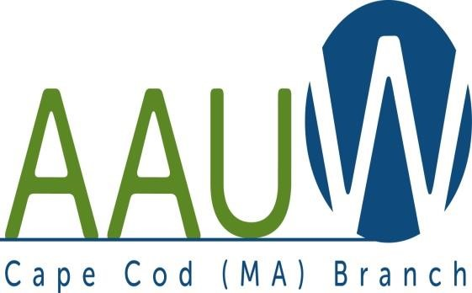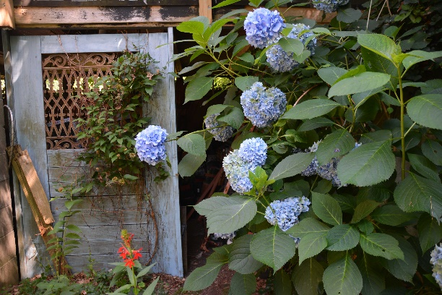
UNIVERSITY WOMAN AAUW-Cape Cod, Massachusetts Branch, est. 1962 Vol. 43 No.1 September 2016

MEET MEHETABLE!
Tuesday September 27, 2016
South Yarmouth United Methodist Church
12 noon gathering
Join us on September 27 as Alice Plouchard Seltzer brings to life one of her “Female Adventurers.” Seltzer has researched and published a volume detailing the lives and accomplishments of twelve unsung heroines from the earliest settlement of Massachusetts and Connecticut. Come meet and hear Mehetable describe her life during the colonization of New England.
Alice Plouchard Seltzer is an author, public speaker, has been a columnist for Prime Time Magazine, as well as an advocate for women and small
REMEMBER TO BRING THOSE BOOKS FOR THE EXCHANGE! This is a perfect time to stock up on porch/beach reading. Members bring books they are finished with (and are willing to part with)—we offer them for $1.00. Bring books, find books.
AAUWAAUWAAUWAAUWAAUWAAUWAAUWAAUWAAUWAAUWAAUWAAUWAAUWAAUWAAUWAAUW

Becky Alden: President Marsha Fredericks: VP Programs Barbara Mulligan and Rado
Phillis Koppel: Secretary Carol Carbaugh: Financial Officer Elsa Murphy: VPs Membership
Phyllis Bradley: VP AAUW Funds

·

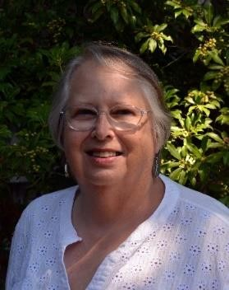
President’s Message:

September, 2016
Ladies, Welcome to the fall on Cape Cod! I hope that you have had a great summer, and that you are looking forward to our next/first meeting. We will meet on Tuesday, September 27 at 11:30 at the South Yarmouth Methodist Church. If you are scheduled to bring sandwiches or dessert, please don’t forget.
We will be having our first Board Meeting starting at 10:30 that same day. Remember anyone may attend our Board Meetings.
Barbara Mulligan-Rado has been working on our Yearbook. If you have not renewed your membership you may not be included in the book….please renew now! Marsha Fredericks has been organizing our programs. And a few of us have been going to local theaters and movies.
As part of this newsletter is announcement from The League of Women Voters. They are pushing to have something in our local schools about Civics and the National Election. I promised to give them some space so we can support them if we can.
Hope to see you at our meeting,
Becky Alden, President Cape Cod Branch
Hello Becky,
I hope you have been enjoying this beautiful summer. When we last met at Bucky's several months ago I spoke to you about the League of Women Voters Civic Education Fund and told you we would be sponsoring a fundraiser. At the time you offered to disseminate information about that fundraiser to your membership. I am giving you two attachments that will let you do that. One is a word document with a text description of the event. The other attachment is a PDF flyer promoting the event. Our event is a comedy performance by Jimmy Tingle, and it will be held on September 25 at 3:00 PM at the Tilden Arts Center at the Cape Cod Community College. Tickets may be purchased in advance online from our website. Thank you for your offer to get the word out about this event. We are looking forward to awarding more mini-grants to middle schools and high schools to support experiential opportunities for civic education.
Best regards,
Karen Mazza
League of Women Voters of the Cape Cod Area
Youth Service Committee Cha

COMEDY FUNDRAISER FOR CIVIC EDUCATION IN SCHOOLS
With Jimmy Tingle
The League of Women Voters of the Cape Cod Area will host a fundraiser with comedian Jimmy Tingle to benefit the League’s grant program to give Cape area schools mini-grants to support experiential opportunities for civic education at the middle school and high school level. The event, “Jimmy Tingle for President”, will be held at the Tilden Arts Center Auditorium at Cape Cod Community College at 3PM on Sunday, September 25. Tickets are $45 and student tickets are $5 with a student ID. Tickets may be purchased online at lwvcapecod.org and are also available at the door.

Jimmy Tingle is a comedian, commentator, activist and entrepreneur. He has worked as a humorist and commentator for “60 Minutes II”, and MSNBC and has appeared on “The Tonight Show,” CNN, “Late Night with Conan O’Brien,” “Fresh Air” with Terry Gross and in his own HBO half-hour comedy special. He is a 2010 graduate of Harvard’s Kennedy School of Government and was that year’s graduate school commencement speaker. His newest project is a social enterprise and solo show entitled, “Humor for Humanity,” which aspires to raise spirits, funds and awareness for nonprofits, charities and social causes.

The grant fund is known as The LWV Civic Education Fund of the Cape Cod Foundation and is the initiative of the LWV of the Cape Cod Area with the support of the LWV of Falmouth. We hope to raise funds to support grants of $750 to each of the Cape area school districts that apply. Information about applying to the grant program or donating is available at www.capecodfoundation.org. The League of Women Voters is a non-partisan organization that encourages the informed and active participation of citizens in government. You may see further information about the grant program on the LWCCA website under civic education including a list of last year’s awardees.
AAUWAAUWAAUWAAUWAAUWAAUWAAUWAAUWAAUWAAUWAAUWAAUWAAUWAAUWAAUWAAUW
Membership News
Yearly dues were due by June 1.See attached form page 6. Please also complete the section at the bottom to update your information for next year’s Yearbook.

AAUWAAUWAAUWAAUWAAUWAAUWAAUWAAUWAAUWAAUWAAUWAAUWAAUWAAUWAAUWAAUW

STUDY AND INTEREST GROUP NEWS
Film Discussion Group: Now that September has arrived, our first meeting of the AAUW film group will be September 21 at 10:00 at Brewster ladies library. I will notify members of the film about ten days before the meeting. Mark your calendars. Let's take a few minutes to discuss any films seen over the summer too although there weren't many good ones! Everyone in AAUW is welcome to join us. .phylliskoppel@comcast.net
The Theater Group: Our group had a summer full of theater outings. More outings to come this fall. Contact Beth Flanagan if you would like to be on her list 362-4319 or bethqf@verizon.net
Cooperative potluck dinners For more information contact Elsa Murphy 896-7661 or elsa.e.murphy@gmail.com.
BOOK GROUPS
Book Group 1 meets on the 1st Thursday. Contact Barbara Fletcher (540-2758) for more information. Book Group 3 meets on 3rd Thursday. Contact Barbara Bracken (362-6195 or bjsjb@comcast.net) for more information.
Book Group 7 meets on 4th Monday. Contact Anne Swanson (428-0914 or goranne@comcast.net) for more information.

AAUW – Cape Cod Branch
2015-2015 Dues and Yearbook Listing
Dues are due by June 1st. Please mail the form below and your payment, payable to Cape Cod Branch AAUW to Judy Needham. You might consider including a donation to the CC Branch (which keeps on $12 of the total dues payment), the local scholarship fund, the Educational Foundation and the Legal Advocacy Fund both of which maintained by AAAUW National. In addition, please update all information so that we can be sure we have your complete and current information for you, our member. Lastly, please consider your willingness to provide refreshments at a branch meeting during the year.

Branch Members* $76.00
Life Members $27.00
Dual Members (with primary membership elsewhere) $12.00
Honorary Life Members** $ 0.00

*$46 of a member’s national dues is tax deductible under AAUW’s 501 (c)(3)
**If you have been a member of AAUW for fifty years.
Please include the coupon below with your check made payable to CC Branch AAUW and mail to: Elsa Murphy: 11 Robbins Hill Rd, Brewster, MA 02631.

Dues_________________________________
Educational Foundation__________________
Legal Advocacy Fund____________________
Scholarship (local)_______________________
Branch_________________________________

TOTAL___________________________

Name:____________________________________
Address:__________________________________
_________________________________________
Phone:___________________________________
eMail:____________________________________

