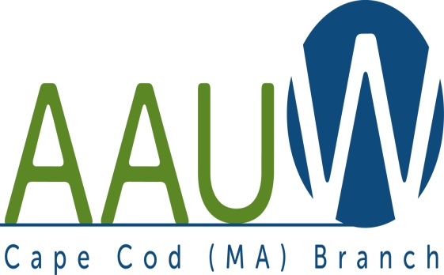 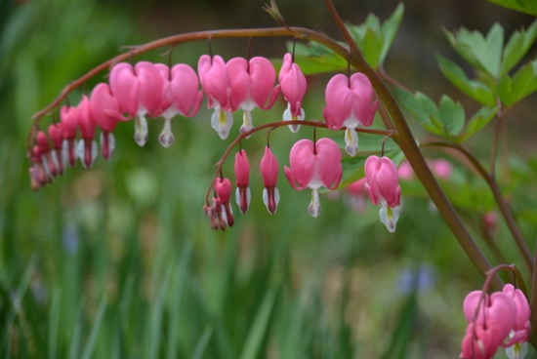

**UNIVERSITY WOMAN AAUW-Cape Cod, Massachusetts Branch, est. 1962 Vol. 42 No.8 May 2016**

**May Meeting: Spring Luncheon**

***Get out your Spring bonnet and join us at the Scargo Café (Route 6A) for our annual spring luncheon and installation of new officers. See pg 5 for more information.***

May 10th Scargo Café RT 6A Dennis 11:30 am

**Program Notes**

**JUNE 28, 2016 –ANNUAL PROGRAM PLANNING MEETING AND SOCIAL**

At 10:00 AM the board will meet to discuss program ideas for the 16-17 year. YOUR input is valuable and valued. Please join us for this discussion OR send your ideas to any member of the board. Each and every suggestion is considered.

At 11:00ish our June social will begin. I will provide a cold soup, bread and beverages. Please bring a dessert or salad to share. Spouses are welcome and this is a wonderful opportunity to bring a friend or neighbor to introduce them to what we are all about. I will have a table set up with executive summaries of AAUW research, information about NCCWSL, fellowships and grants, AND MEMBERSHIP! Join us and bring a guest!

**BOOK AND AUTHOR TEA: Tuesday June 21 2:00 pm at the Cape Codder. See Page 4!!!**

**FYI: AAUW STATE CONVENTION (MAY 7 in Boston) KEYNOTE SPEAKER:** Ms. Lakshmi Puri (India) is Assistant Secretary-General of the United Nations and Deputy Executive Director of UN Women, responsible for the Bureau for Intergovernmental Support, UN System Coordination, and Strategic Partnerships, and was the interim head of UN Women from March to August 2013. She has steered UN Women’s engagement in major intergovernmental processes, such as the Commission on the Status of Women, including the landmark outcomes of the 57th and 58th sessions, as well as the historic 59th session on the 20-year anniversary of the Beijing Declaration and Platform for Action, which resulted in a Political Declaration by which Member States pledged to take concrete steps to ensure the full, effective and accelerated actions to achieve gender equality and the empowerment of women. Ms. Puri has been at the forefront of UN Women’s intergovernmental work on Sustainable Development, Climate Change, Financing for Development, Health, Information Society, Youth, Migration, Women, Peace and Security, the Urban Agenda and Humanitarian Action.Puri also had a distinguished 28-year career with the Indian Foreign Service.

**Becky Alden**

President

**Fran Ziegler Sheila Mennell**

Financial Officer Recording and Correspondence Secretary

* **Phyllis Bradley Marsha Fredericks Judith Needham**

Vice President, AAUW Funds Vice President, Programs Vice President, Membership

**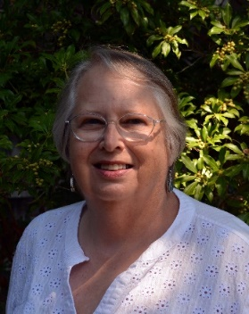****President’s Message:**

May, 2016

Thank you all for great Annual Meeting in April! We have updated Bylaws – thanks to Regina Mullen. (You didn’t miss the vote on the amended Bylaws because they just had to corrected to match the national guidelines and then resubmitted by May 15th.) Thank to Elsa Murphy and her committee, we have officers ready to install at our May Luncheon at Scargo Café on the tenth. Plus we learned about that body of water that makes Cape Cod a man-made island – which we have to cross when “we go over the bridge”.

Special thanks go to Judy Needham, our Vice President for Membership, and to Fran Ziegler, our Finance Officer, for all the work they have done the past four years! Thank you, both, for the many hours you have devoted to keeping our records straight, but especially for your support of our Cape Cod Branch!

I hope to see many of you at the state convention on May 7th in Boston, then at our luncheon on the 10th. Let’s keep talking about Equal Pay to our family and friends, especially since it may be voted on in Massachusetts this spring. The bill has passed the Senate, now for the House….

Becky Alden, President

**HELP WANTED!**

Last year we sent two young women from CCCC to NCCWSL. We had NO applications for our $600. Scholarship this year. We need a small committee to promote this program and choose scholarship recipients. This job involves sending the information to CCCC and MMA, perhaps writing an article for the school newspapers, distributing and collecting applications, and choosing one or two recipients. Much of this can be done by email and you are not expected to attend EVERY branch/board meeting. Please contact Becky Alden if you would be willing to take this on. NCCWSL is a wonderful leadership opportunity for young women from Cape Cod and we are fortunate to be able to offer it. Thank you!!**BOARD OF DIRECTORS**

**More Opportunities to HELP**

Members Liz Groves and Sheila Mennell are having a combined yard sale at the Grove’s home in Harwich Port Sat. June 11th.  We will provide a tent and tables, with no cost to the Branch, but need members to work at the sale.    We think 3 time periods with 2 people at each slot should work out:  7-9 am to set up and get started-  9-11 is already covered (thank you Elsa and Barbara Bracken) and  11-1: Carol Mitchel has signed up.  We find that by 1-2 pm most of the activity is over and, if people do come by, there will be both Liz and myself with our ‘helpers’ (family) there to continue. Of course, we would be pleased to have additional members to join in at any time, especially in the 9-11 slot which is often busiest.

Please be in touch with Sheila  [mennell@comcast.net](mailto:mennell@comcast.net) or [508/432-3854](tel:508%2F432-3854) if you can spare some time to help in this event.  As before, all proceeds will go to the NICWSL fund**.**

**Membership News**

Yearly dues are due by June 1.See attached form page 6. Please also complete the section at the bottom to update your information for next year’s Yearbook

***AAUWAAUWAAUWAAAUWAAUWAAUWAAUWAAUWAAUWAAUWAAUWAAUWAAUW***

**AAUW – Cape Cod Branch**

**STUDY AND INTEREST GROUP NEWS**

Keep bringing books you want to share for the book exchange. The small price of one dollar a book adds to our funds and your reading pleasure.  If the books you bring do not sell, please pick them up at the end of the meeting.  We cannot store extra donations.

**Film Discussion Group:** After May we will take a break for the Summer. Film for May is “Mother’s Day” a heart-warming comedy. Join us any time the third Wednesday of the month, 10:00 at the Brewster Ladies Library.[phylliskoppel@comcast.net](mailto:phylliskoppel@comcast.net)

C:\Users\Alice\AppData\Local\Microsoft\Windows\Temporary Internet Files\Content.IE5\9T9R88ZQ\MC900217144[1].wmfThe **Theater Group**: Recently went to see Diary of Anne Frank at Cape Cod Theater Company. Many more outings to come this spring and summer. Contact Beth Flanagan if you would like to be on her list 362-4319 or [bethqf@verizon.net](mailto:bethqf@verizon.net)

 **Cooperative potluck dinners** For more information contact Elsa Murphy 896-7661 or [elsa.e.murphy@gmail.com](mailto:elsa.e.murphy@gmail.com).

**BOOK GROUPS**

Book Group 1 meets on the 1st Thursday.  Contact Barbara Fletcher (540-2758) for more information.

Book Group 3 meets on 3rd Thursday. Contact Barbara Bracken (362-6195 or [bjsjb@comcast.net](mailto:bjsjb@comcast.net))  for more information.

Book Group 7 meets on 4th Monday.  Contact Anne Swanson (428-0914 or [goranne@comcast.net](mailto:goranne@comcast.net)) for



Book and Author Tea

Sponsored by the

American Association of University Women / Cape Cod

Tuesday, June 21, 2016 at 2:00 p.m.

# Cape Codder Hotel

1225 Iyannough Road (Route 132) • Hyannis, MA

Featured Authors

PATRY FRANCIS ELIN HILDERBRAND

DIANA MARTIN NANCY THAYER

Moderated by

Mindy Todd, host of “The Point” on the Cape & Islands NPR Stations.

Tickets are $40. Send checks, made payable to *AAUW/CC* to Phyllis

Rubin, 17 Whittemore Avenue, Falmouth, MA 02540

For information, Call 508-540-9029 or phyllisaauw@comcast.net

This event benefits the AAUW / Cape Cod Scholarship Fund awarded to a Cape Cod woman returning to college.

*AAUW of Cape Cod Spring Luncheon*

**Where**: Scargo Café in Dennis

**When**: May 10, 2016 Social 11:30 Luncheon 12:00

**Cost**: $24.00 per person Tax & Tip included Cash Bar

Menu

 Starters

Tossed Green Salad/red wine vinegar

Or Clam Chowder

Entrees

Vegetable Stir Fry

Braised Short Ribs/mashed potatoes

Lemon Parmesan Chicken/linguini Dessert

Raspberry Sorbet

Grapenut Custard Pudding

Strawberry Cheese Cake

*All lunches include bread, Coffee or Tea or Soft Drink Selection*

Name………………………………………………………………

Telephone:…………………………………………………

Email………………………………………………………………………………………….

Select one choice from each category. Checks made out to AAUW/Cape Cod and given or

**th** mailed to: Fran Ziegler, 1378 Bumps River Road, Centerville, MA 02632 by **May 5 ! Very important, as Scargo must get their order in! We can accommodate 30 people so get your order in as early as possible.**

AAUW – Cape Cod Branch

**2016-2017 Dues and Yearbook Listing**

Dues are due by June 1st. Please mail the form below and your payment, payable to Cape Cod Branch AAUW to Judy Needham. You might consider including a donation to the CC Branch (which keeps on $12 of the total dues payment), the local scholarship fund, the Educational Foundation and the Legal Advocacy Fund both of which maintained by AAAUW National. ***In addition, please update all information so that we can be sure we have your complete and current information for you, our member***. Lastly, please consider your willingness to provide refreshments at a branch meeting during the year.

Branch Members* $76.00

Life Members $27.00

Dual Members (with primary membership elsewhere) $12.00

Honorary Life Members** $ 0.00

*$46 of a member’s national dues is tax deductible under AAUW’s 501 (c)(3)

**If you have been a member of AAUW for fifty years. Please include the coupon below with your check made payable to CC Branch AAUW and mail to: Judy Needham, 9 River Drive, So. Yarmouth, MA 02664-3139

**Dues_________________________________**

**Educational Foundation__________________**

**Legal Advocacy Fund____________________**

**Scholarship (local)_______________________**

**Branch_________________________________**

# TOTAL___________________________

**NAME_________________________________________ BIRTHDAY______________**

**ADDRESS_____________________________________________________________**

**UNIVERSITY & DEGREE(S) and YEAR______________________________________**

### PHONE_______________________EMAIL___________________________________

**\*I would like to provide refreshments for a Branch meeting. Months(s) preferred______________________ *_________*or when needed_________. *I ____regularly ____sometimes ______seldom attend monthly meetings.***

***_____I am unable to help at this time.***

***SIGNATURE_____________________________________***