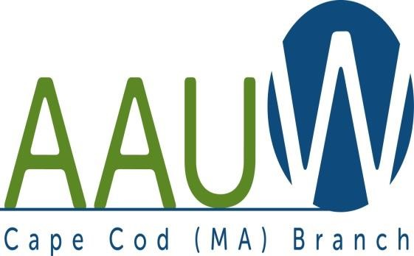
UNIVERSITY WOMAN AAUW-Cape Cod, Massachusetts Branch, est. 1962 Vol. 42 No.9 June2016

June 2016-2017 Planning Meeting and Luncheon 10:00 am June 28th
Marsha Frederick’s 23 Tempus Way East Dennis 02641
New and prospective members, please join us for an opportunity to meet and get acquainted with other members of the Cape Cod branch. Members, this is a perfect opportunity to bring a friend, family or neighbor (spouses, too) to show them what we are all about. (Great birding at my home, too!)
Executive summary copies of the newest AAUW research, “Barriers & Bias—The Status of Women in Leadership” will be available, as well as other AAUW publications.
REMEMBER TO BRING THOSE BOOKS FOR THE EXCHANGE! This is a perfect time to stock up on porch/beach reading. Members bring books they are finished with (and are willing to part with)—we offer them for $1.00. Bring books, find books.
*****MEMBERS are asked to bring a salad or dessert to share. I will provide cold soup, bread and beverages.****
At 10am the board, and ANY interested branch members will suggest and determine speakers and programs for the 2016-17 meeting year. If you have ideas, or strong preferences, this is your opportunity to be heard and for your suggestions to be acted on. THIS IS YOUR BRANCH! Please come and help us make it relevant, interesting and informative for YOU. All suggestions are seriously considered. (You do not have to make the arrangements for your suggestion—the VP of programs does that!)
Hope to see you all on the 28! (How much traffic can there be on a Tuesday morning???)
Note: The Jewelry/Yard Sale planned for June 11th has been postponed for personal reasons.
Becky Alden
President
Fran Ziegler Sheila Mennell
Financial Officer Recording and Correspondence Secretary
· Phyllis Bradley Marsha Fredericks Judith Needham
Vice President, AAUW Funds Vice President, Programs Vice President, Membership

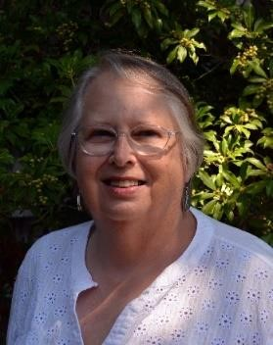
President’s Message:

June, 2016
This is the last Newsletter until the beginning of our new year in September. We had a wonderful Spring Luncheon at the Scargo Café and installed our new officers: Membership will be shared by Barbara Mulligan Rado and Elsa Murphy, Recording Secretary: Phyllis Koppell and Treasurer: Carol Carbaugh. We thanked our out-going officers Judy Needham, Membership; Fran Ziegler, Treasurer, and Sheila Mennell, Recording Secretary. I wish everyone a great summer. Hope to see you at our June meeting and lunch on the 28th at Marsha’s house. Come with your ideas for next year’s programs and enjoy lunch with friends. If you can’t make it - See you all at our September meeting - the 27th.
Becky Alden, President
Membership News
Yearly dues were due by June 1.See attached form page 6. Please also complete the section at the bottom to update your information for next year’s Yearbook

BOOK AND AUTHOR TEA: There is still time to register! Tuesday June 21 2:00 pm at the Cape Codder.

AAUW – Cape Cod Branch
STUDY AND INTEREST GROUP NEWS
Film Discussion Group: After May we will take a break for the Summer. Here are the films we saw and discussed this year: Please consider joining our lively discussions next year. We meet the third Wednesday of the month, 10:00 at the Brewster Ladies Library.phylliskoppel@comcast.net
October: Grandma November: Suffragette
December: Brooklyn January: The Danish Girl
February: Spotlight March: The Big Short
April: Eye in the Sky May: Dough
The Theater Group: Many more outings to come this summer. Contact Beth Flanagan if you would like to be on her list 362-4319 or bethqf@verizon.net
Cooperative potluck dinners For more information contact Elsa Murphy 896-7661 or elsa.e.murphy@gmail.com.
BOOK GROUPS
Book Group 1 meets on the 1st Thursday. Contact Barbara Fletcher (540-2758) for more information. Book Group 3 meets on 3rd Thursday. Contact Barbara Bracken (362-6195 or bjsjb@comcast.net) for more information.
Book Group 7 meets on 4th Monday. Contact Anne Swanson (428-0914 or goranne@comcast.net) for

Book and Author Tea
Sponsored by the
American Association of University Women / Cape Cod
Tuesday, June 21, 2016 at 2:00 p.m.
Cape Codder Hotel

1225 Iyannough Road (Route 132) • Hyannis, MA

Featured Authors
PATRY FRANCIS ELIN HILDERBRAND

DIANA MARTIN NANCY THAYER

Moderated by
Mindy Todd, host of “The Point” on the Cape & Islands NPR Stations.

Tickets are $40. Send checks, made payable to AAUW/CC to Phyllis
Rubin, 17 Whittemore Avenue, Falmouth, MA 02540
For information, Call 508-540-9029 or phyllisaauw@comcast.net

This event benefits the AAUW / Cape Cod Scholarship Fund awarded to a Cape Cod woman returning to college.

2016-2017 Dues and Yearbook Listing
Dues are due by June 1st. Please mail the form below and your payment, payable to Cape Cod Branch AAUW to Judy Needham. You might consider including a donation to the CC Branch (which keeps on $12 of the total dues payment), the local scholarship fund, the Educational Foundation and the Legal Advocacy Fund both of which maintained by AAAUW National. In addition, please update all information so that we can be sure we have your complete and current information for you, our member. Lastly, please consider your willingness to provide refreshments at a branch meeting during the year.
Branch Members* $76.00
Life Members $27.00
Dual Members (with primary membership elsewhere) $12.00
Honorary Life Members** $ 0.00
*$46 of a member’s national dues is tax deductible under AAUW’s 501 (c)(3)
**If you have been a member of AAUW for fifty years. Please include the coupon below with your check made payable to CC Branch AAUW and mail to: Judy Needham, 9 River Drive, So. Yarmouth, MA 02664-3139
Dues_________________________________
Educational Foundation__________________
Legal Advocacy Fund____________________
Scholarship (local)_______________________
Branch_________________________________

TOTAL___________________________

NAME_________________________________________ BIRTHDAY______________

ADDRESS_____________________________________________________________ UNIVERSITY & DEGREE(S) and YEAR______________________________________

PHONE_______________________EMAIL___________________________________

*I would like to provide refreshments for a Branch meeting. Months(s) preferred______________________ _________or when needed_________. I ____regularly ____sometimes ______seldom attend monthly meetings.
_____I am unable to help at this time.
SIGNATURE_____________________________________

