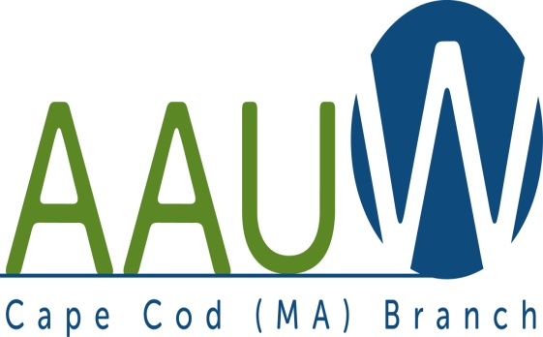 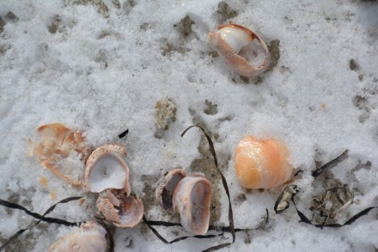

**UNIVERSITY WOMAN AAUW-Cape Cod, Massachusetts Branch, est. 1962 Vol. 42 No.5 February 2016**

**February Meeting:**

**Date: Tuesday February 23,  12:00 p.m. NOON GATHERING AND SOCIAL TIME—LUNCH AT 12:30—SPEAKER AT 1:00**.

**Meeting Location:** South Yarmouth United Methodist Church 322 Old Main St. South Yarmouth

**Women of the Civil War**

Brenda Collins, Civil War re-enactor, will introduce us to the many women of the Civil War era, the roles they played both in the war and on the home front, and the ways in which their contributions changed society. Brenda is a guide for the Harwich Historical Society and a well-known speaker here on Cape Cod. Be sure to join us!

**TITLE IX** -- A big thank you to all who took Title IX folders for your community schools. I have heard back from several of you, but am waiting for the rest. If you have not yet had the opportunity to make an appointment and deliver “the goods,” please do so soon. I would like to hear from all by the March meeting. If you are unable to do this, please contact me and I will arrange to do it. Thank you. Marsha

**The JEWELY SALE** has been resurrected! We will have a table at the Historical Society of Old Yarmouth Indoor Yard Sale on SATURDAY MARCH 12, 2016 from 9-3 at the Yarmouth Senior Center, 528 Forest Road S. Yarmouth. We need two teams to be in charge—one for set up, one for clean up. I will be away (bad timing) Two to four women should be able to handle the table during the day. The day can be divided – 8:30 (set up) to 11, 11-1 and 1-3:30 (clean up). The jewelry will be priced, cleaned and sorted. All you have to do is make an appealing presentation of it. Please contact me at 508-694-6279 or [busywomancc@comcast.net](mailto:busywomancc@comcast.net) to volunteer for a time slot. Thank you. Marsha

Anyone who is available to help clean and sort please come to my home, 23 Tempus Way, East Dennis Thursday February 4th at 10am and/or Tuesday February 9th at 10am.

PLEASE REMEMBER –The diversity book for March discussion is “I AM Malala”. Fran Zeigler still has several copies for sale. They will be available at the meeting.

Thanks, Marsha (508-694-6279)

***AAUWAAUWAAUWAAAUWAAUWAAUWAAUWAAUWAAUWAAUWAAUWAAUWAAUW***

**BOARD OF DIRECTORS**

**Becky Alden**

President

**Fran Ziegler Sheila Mennell**

Financial Officer Recording and Correspondence Secretary

* **Phyllis Bradley Marsha Fredericks Judith Needham**

Vice President, Vice President, Vice President,

AAUW Funds Programs Membership

**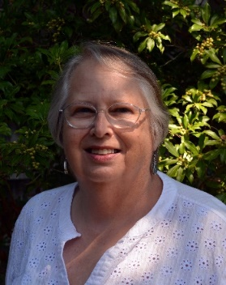****President’s Message: January 28, 2016**

We had an educational, wonderful meeting at the Zion Union Heritage Museum. Thank you, Marsha, for arranging the day. John Reed, Director, was a wonderful host. We admired and heard the history of the many icons done by artist Pamela Chatterton Purdy. We meet next on February 23rd at the South Yarmouth Methodist Church at twelve.

There are some upcoming events which will need staffing. Please look at your calendar and see when you might be available and please plan on registering to help during our February meeting. (Or if you can’t attend in February, please contact me at [raalden@capecod.net](mailto:raalden@capecod.net))

Saturday, March 12, from 9-3, will be our Jewelry Sale at the Yarmouth Senior Citizen Center. Marsha is still looking for our old jewelry to sell. Last chance to give her your old, or broken, jewelry is at the February meeting.

Equal Pay Day is on Tuesday, April 12. Our Board has decided that we will try to have a table at Mass Maritime during their lunch time, and to be at the Cape Cod Mall. We hope to have a poster created that list the other “Equal Pay Days”. Arrangements are in process, but please mark your calendar now.

Our State AAUW Convention is scheduled for Saturday, May 7th, hosted by the Boston Branch at the Harvard School of Public Health. Please plan on joining us as we carpool up on that day.

I hope that everyone is reading our book I am Malala, by Malala Yousafzai for our March meeting. We will plan on having the book discussion at eleven before our meeting on the 22nd.

Our Book and Author Tea is being planned for June 21st at the Cape Codder, Hyannis. Please start inviting your friends to this major event that we hold every other year.

Finally, I want to invite you to the Cape Cod Women’s Coalition celebration of International Women’s Day on March 4th from 7:15 to 10:00. Please look for the announcements coming soon. We hope to have a video welcoming us to the breakfast from Senator Warren again this year. International Women’s Day is celebrated in many countries – much more than we do in this country.

I hope everyone keeps warm and healthy. Hopefully we won’t have the snow problem we had last winter. See you in February.

*Becky Alden, President*

***AAUWAAUWAAUWAAAUWAAUWAAUWAAUWAAUWAAUWAAUWAAUWAAUWAAUW***

**MEMBERSHIP NEWS**

**Memoriam***: Isobel Margaret (Kriegel) Rossello,* aged 92, died peacefully on Jan. 2, 2016 at Harbor Point after a period of declining health

Also:  *Marie Appelbaum*, former member lost her husband in January

**Congratulations** to Member *Barbara Burgo* who has been appointed to the Human Rights Commission for Barnstable County.

**Our field trip to Zion**

Our field trip to the Zion Union Heritage Museum was terrific! After lunch we all met in the original Zion Union Mission Chapel (built in 1909) surrounded by gold leaf icons of the Civil Rights Movement. The icon creators, Pamela Chatterton-Purdy and her author husband, Rev. David Purdy were on hand to give us the history of the icons and some personal civil rights stories. John Reed, President of museum and its Board of Directors presented a history of the site and its mission to be a cultural home for people of color including African Americans, Cape Verdeans, Wampanoag Native Americans, and more recently Brazilians, Hattians, and Jamaicans making Cape Cod their home. We were treated to an informative video detailing the history of the Cape’s people of color, the abolitionist movement, civil rights and the flowering of local art, music and theater related to this diverse culture.

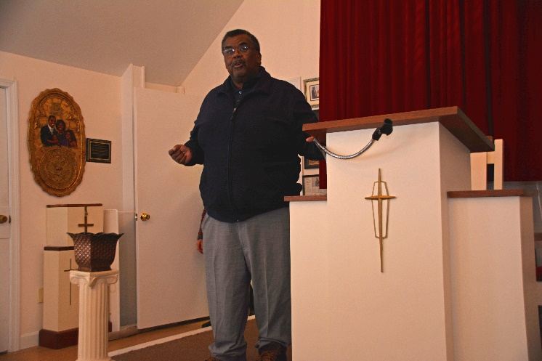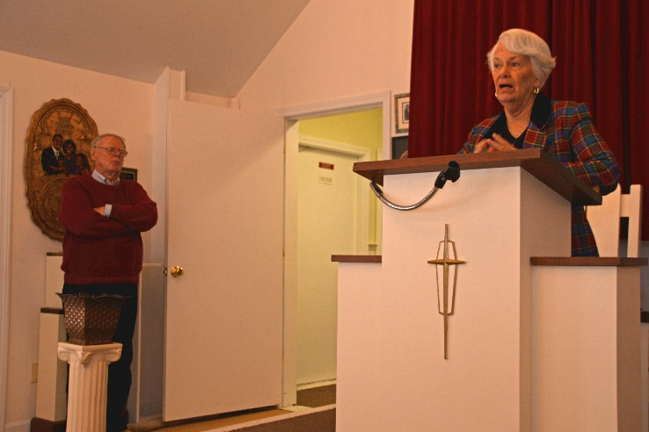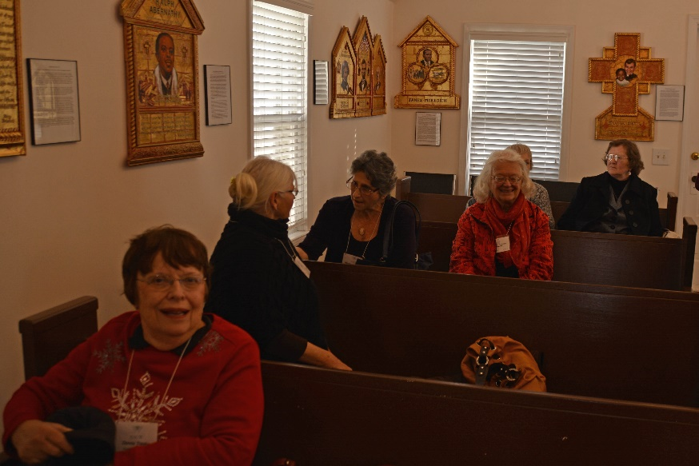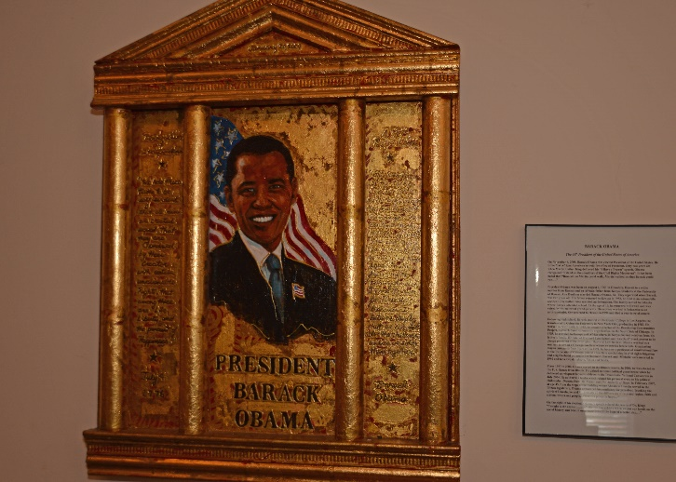

**From top left to right Mr. John Reed President of the Zion Heritage Museum; Pamela and David Purdy icon makers; AAUW members Sitting in the chapel;**

**Icon of President Barack Obama**

***AAUWAAUWAAUWAAAUWAAUWAAUWAAUWAAUWAAUWAAUWAAUWAAUWAAUW***

**AAUW – Cape Cod Branch**

**STUDY AND INTEREST GROUP NEWS**

The response to the request for donation to the Book Exchange resulted in a good selection of titles.  Keep bringing books you want to share to each branch meeting.  The small price of one dollar a book adds to our funds and your reading pleasure.  If the books you bring do not sell, please pick them up at the end of the meeting.  We cannot store extra donations.

**Film Discussion Group:** We continue to meet monthly and are enjoying some lively discussions. Next film is “Spotlight”. If anyone would like to join us we will be meeting Wed. February 17, at 10:30 at the Brewster Ladies Library. Possible lunch gathering afterwards..Other questions, please email Phyllis at [phylliskoppel@comcast.net](mailto:phylliskoppel@comcast.net)

C:\Users\Alice\AppData\Local\Microsoft\Windows\Temporary Internet Files\Content.IE5\9T9R88ZQ\MC900217144[1].wmfThe **Theater Group**: We were snowed out for our last event, but are looking forward to our next play, TBD.



**Our bi-monthly Birthday Celebrations** will start again shortly. Pam Berube will be contacting you if your birthday falls in the winter months.

**Cooperative potluck dinners** The Cooperative Dinners will be held at lunchtime (1:00 p.m.) during the dark winter months.  We welcome newcomers.  For more information contact Elsa Murphy 896-7661 or [elsa.e.murphy@gmail.com](mailto:elsa.e.murphy@gmail.com).

**BOOK GROUPS**

Book Group 1 meets on the 1st Thursday.  Contact Barbara Fletcher (540-2758) for more information.

Book Group 3 meets on 3rd Thursday. Contact Barbara Bracken (362-6195 or [bjsjb@comcast.net](mailto:bjsjb@comcast.net))  for more information.

 Book Group 7 meets on 4th Monday.  Contact Anne Swanson (428-0914 or [goranne@comcast.net](mailto:goranne@comcast.net)) for more information.