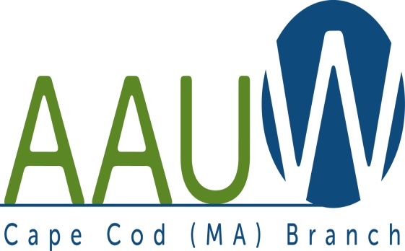 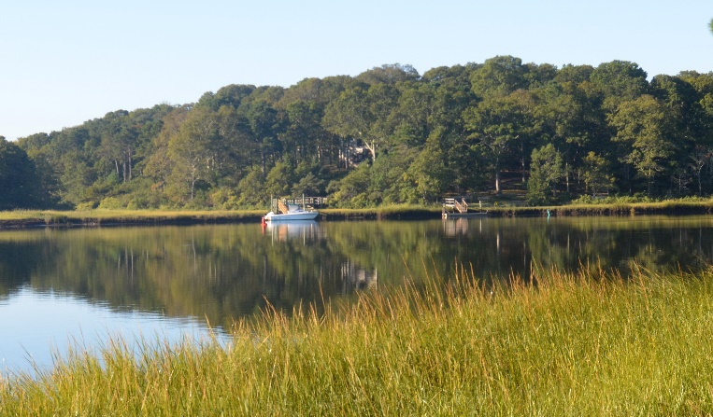

**UNIVERSITY WOMAN AAUW-Cape Cod, Massachusetts Branch, est. 1962 Vol. 42 No.1 September 2015**

**NOTE: September Meeting moved to Tuesday, September 15, 12:00 pm. Board Meeting at 10:30. GATHERING AND SOCIAL TIME AT NOON—LUNCH AT 12:30, Speakers 1:00**

**Meeting Location:** South Yarmouth United Methodist Church 322 Old Main St. South Yarmouth

Program

NCCWSL, NCSD AND STEM, OH MY!!!

Do you still wonder what NCCWSL means and why we provide financial support for young women from our C/U partners to attend? Then this is the meeting for you! Come hear Elise, April and Elizabeth tell us about their experiences at the University of Maryland.

National Convention San Diego -- Pam Berube and Marsha Fredericks will offer brief highlights of the 2015 national convention. Plan to join us in Washington DC in 2017!

STEM (and GIRLS!) RULE!! Four members of AAUW MA were in attendance at the Envision the Future STEM camp held at Bridgewater State University in July. Bo Bowen, who commuted daily to the campus, and took well over 400 pictures, will fill you in on what happened and how we plan to move forward bringing a STEM camp to Cape Cod.

Don’t miss this meeting!

***AAUWAAUWAAUWAAAUWAAUWAAUWAAUWAAUWAAUWAAUWAAUWAAUWAAUW***

**BOARD OF DIRECTORS**

**Becky Alden**

President

**Fran Ziegler Sheila Mennell**

Financial Officer Recording and Correspondence Secretary

* **Phyllis Bradley Marsha Fredericks Judith Needham**

Vice President, Vice President, Vice President,

AAUW Funds Programs Membership

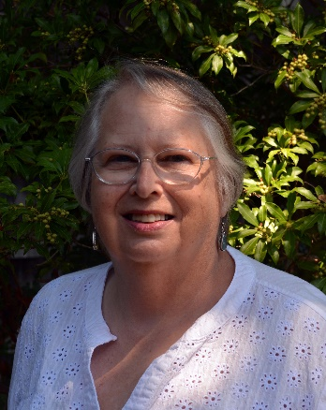

**PRESIDENT’S MESSAGE August 24, 2015**

Welcome everyone to another year for AAUW! I am looking forward to meeting all of you in September at our first meeting. Marsha Fredericks, our past President and now VP for Program, has been working hard getting some great programs for us.

Marsha and Alice Bowen also attended the weeklong STEM program held at Bridgewater State College. They have invited our two adjoining Branches to join us in planning and running a one-day similar program next summer. We hope to apply for an AAUW grant to help us with this. Come to the meeting and learn more about it.

Book Exchanges: I hope that we can continue and improve our book exchanges at our meetings. Didn’t you have a “summer read” that you want to share with another member. I do, and they are sitting by my back door ready for September. Why don’t you bring yours? Maybe I will put in a donation so I can take you book home with me. This way we share our books and bring in a little extra money into our treasury.

I understand that our Program Booklet with our membership information is in process and should be ready in October.

The Board will be meeting at 10:30 before our general meeting and program. It is an open meeting, so you are always welcome to attend.

Thank you to everyone who has been working over the summer to help our Cape Cod Branch get ready for the fall. See you on September 15 at the South Yarmouth Methodist Church, South Yarmouth.

Becky Alden, President

***AAUWAAUWAAUWAAAUWAAUWAAUWAAUWAAUWAAUWAAUWAAUWAAUWAAUW***

**MEMBERSHIP**

We have been collecting dues and these names will be in the Yearbook in October. Also, Please welcome our newest members!  
  
**PATRICIA CLARK**  
University of Colorado, Boulder  
Boston University, MA, PhD  
  
**PHYLLIS KOPPEL**  
New York University, BS  
Wesleyan University, MA  
(Phyllis is a dual member with the Sarasota, Florida branch)  
  
Judy Needham Membership VP

***AAUWAAUWAAUWAAAUWAAUWAAUWAAUWAAUWAAUWAAUWAAUWAAUWAAUW***

**AAUW – Cape Cod Branch**

**STUDY AND INTEREST GROUP NEWS**

We have a new interest group forming this year suggested by a recent member.  Phyllis Koppel would like to organize a film discussion group.  Members would see current films showing at local theaters at their convenience and meet later to discuss them.  If you are interested Phyllis would like to hear from you.

(237-3169 or [phylliskoppel@gmail.com](mailto:phylliskoppel@gmail.com))

There will also be a review of this venture and of all our interest and study groups at the September branch meeting.

C:\Users\Alice\AppData\Local\Microsoft\Windows\Temporary Internet Files\Content.IE5\9T9R88ZQ\MC900217144[1].wmf

The **Theater Group** has been active during the summer and will continue to offer opportunities to attend plays.  Contact Beth Flanagan if you would like to be on her list (362-4319 or [bethqf@verizon.net](mailto:bethqf@verizon.net))

**Our bi-monthly Birthday Celebrations** will start shortly for September and October celebrants.  Pam Berube will be contacting you if your birthday falls in these months.

**Cooperative potluck dinners** will also resume this fall.  Contact Elsa Murphy (896-7661 or [elsa.e.murphy@gmail.com](mailto:elsa.e.murphy@gmail.com)) to be added to list of interested diners.

 **BOOK GROUPS**

Book Group 1 meets on the 1st Thursday.  Contact Barbara Fletcher (540-2758) for more information.

Book Group 3 meets on 3rd Thursday. Contact Barbara Bracken (362-6195 or [bjsjb@comcast.net](mailto:bjsjb@comcast.net))  for more information.

Book Group 7 meets on 4th Monday.  Contact Anne Swanson (428-0914 or [goranne@comcast.net](mailto:goranne@comcast.net)) for more information.

Book Group 9 has disbanded unfortunately.

 There will be sign-up sheets for all groups at the September branch meeting.

Suggestions for new activities are always welcome. Elsa Murphy