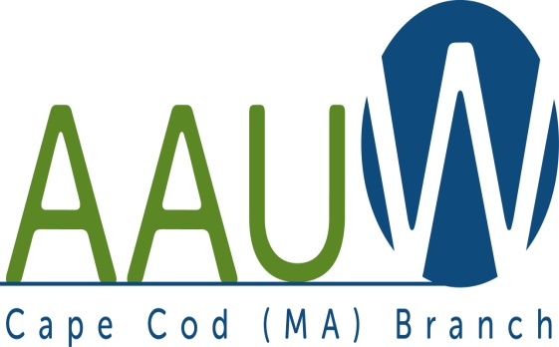 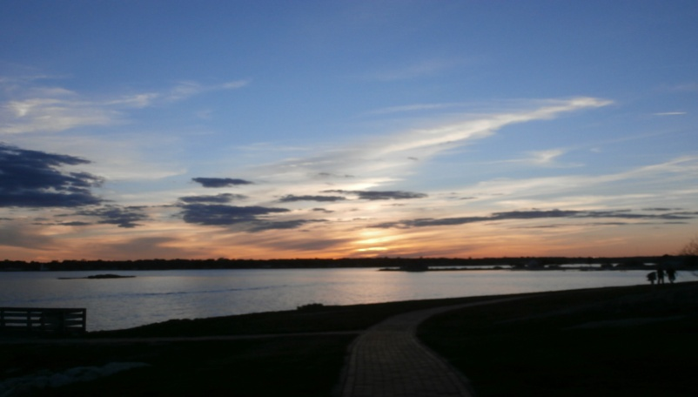

**UNIVERSITY WOMAN AAUW-Cape Cod, Massachusetts Branch, est. 1962 Vol. 41 No.6 April 2015**

**April Meeting Tuesday, April 28th**

12:00 p.m. NOON GATHERING AND SOCIAL TIME—LUNCH AT 12:30—SPEAKER AT 1:00.

**PROGRAM Colette Buchanan** 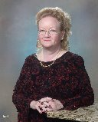

Colette Buchanan grew up in Boston, attended St. Thomas Aquinas College, was appointed as executive secretary to the chief legal counsel to the governor and worked in the State House. Colette is semi-retired today, but still works part-time as assistant to the executive secretary of the Massachusetts Society of Mayflower Descendants at the Society's headquarters in Hingham. Colette became a published author recently with the release of her new book ***Bit of a Witch***and will be delighted to speak about that and the aftermath associated with marketing and promotion. Colette was featured as a new author at the Boston Book Festival and ***Bit of a* *Witch***continues to be offered at Titcomb's Bookshop in East Sandwich. Colette has many sides to her and all of them are humorous. She will entertain, inform and express herself with warmth and dignity.

**WE WILL BE MEETING AT THE SOUTH YARMOUTH METHODIST CHURCH. IT IS LOCATED AT 322 OLD MAIN STREET, right across from the Hess Gas Station.**

**AAUWAAUWAAUWAAAUWAAUWAAUWAAUWAAUWAAUWAAUWAAUWAAUWAAUW**

**BOARD OF DIRECTORS**

Marsha Fredericks

President

Fran Ziegler Sheila Mennell

Financial Officer Recording Secretary

Rebecca Alden Carol Mitchell Judith Needham

Vice President, Vice President, Vice President,

AAUW Funds Programs Membership

**AAUWAAUWAAUWAAAUWAAUWAAUWAAUWAAUWAAUWAAUWAAUWAAUWAAUW**

**PRESIDENT’S MESSAGE MARCH 2015 **

AAUW APRIL 2015

April showers bring May flowers. Now that the snow is finally gone and rains have started, maybe we’ll get those flowers. The town parking lot behind our new meeting place is emptier now, but there is additional parking in the strip mall lot next door AND the South Yarmouth Library lot, which is behind the library. I will remember to bring our sign, so you will know where our meeting place is located.

April 14 is EQUAL PAY DAY. Cape Cod branch will be participating in two activities this year. There will be a meeting at the State House in Boston hosted by the MA Caucus of Women Legislators and other women’s organizations including AAUW, from 2-5pm. I will be attending. It is not too late to accompany me—I’d love the company! The Cape Cod Branch will be staffing a table at the Cape Cod Mall for the second year to educate the public regarding equal pay. We will have a table near the food court from 2-6pm. The following members have volunteered to staff the table –2-4pm Bo Bowen, Shelia Mennell and Lyn Solomon; 4-6pm Becky Alden and Cynthia Hope. If you are available and would like to join these ladies, please do so.

The May luncheon will be held at Riverway on Route 28, South Yarmouth. Please see the Reservation form included in this newsletter.

We still do not have anyone(s) to take the helm for the next two years. Perhaps we need a rotating president? Someone to open the meeting and make announcements? We also have no programs VP……….

The Board will have a luncheon meeting on Tuesday June 9th at 10:30am at my home, 23 Tempus Way, East Dennis. We will propose a budget for the next fiscal year and set up programs for the 2015-16 year. EVERY MEMBER of the organization is invited and encouraged to attend this meeting. Anyone with ideas for programming should come with those ideas and we can begin programming at the meeting. Without a program VP, we will need one person per month to set up a program per month. Suggestions and ideas will be discussed and we hope to see many of you at this meeting.

Marsha

**AAUWAAUWAAUWAAAUWAAUWAAUWAAUWAAUWAAUWAAUWAAUWAAUWAAUW**

**AAUW Luncheon**

The Riverway Lobster House 1338 Rte. 28 S. Yarmouth

Tuesday May 12, 2015 Noon arrival

Upon Arrival:

Cheese, Fruit & Crudités Cash Bar

To Start:

Quahog Chowder or Soup of the Day

Entrée Selection:

Spring Salad:

Spring mixed greens, mandarin oranges, avocado, sliced almonds, shaved fennel, red onion & grape tomatoes tossed with citrus vinaigrette

Your choice of salad toppings-

Sliced Tavern Tenderloin

Grilled Salmon

Grilled Chicken

Dessert

Chocolate Pave

Coffee, tea & soft drinks included

$26 per person inclusive of tax & gratuity-__________________________________________________________________________________________

NAME:(s)_________________________________________________________________________________

MEAL CHOICE: Tenderloin_______ Salmon________________ Chicken_________________

AMOUNT ENCLOSED: $_______________________

PLEASE SEND CHECK TO: SHEILA MENNELL 66 MILES ST. HARWICH PORT, MA 02646

CHECKS MUST BE RECEIVED NO LATER THAN SATURDAY MAY 9TH.

**AAUWAAUWAAUWAAAUWAAUWAAUWAAUWAAUWAAUWAAUWAAUWAAUWAAUW**

**Equal Pay Day April 14th**

**Equal Pay Day** — the annual day in April that symbolizes how long it takes for women’s earnings to catch up to men’s earnings from the previous year — is a powerful opportunity to organize action in our communities.

This year, given all the public attention to pay equity, increased legislative activity at the state level, and the possibility of new developments on the federal level, AAUW National is confident that we can surpass the [number of events held in 2014](http://www.aauw.org/article/how-to-equal-pay-day/). Our Cape Cod Branch will be hosting a booth at the Cape Cod Mall from 2pm – 8pm and we are looking for at least two members each hour to sign up to cover our booth. Bo was asked to look into this date as it intrigued her. In 1971 when she started teaching the Equal Pay Day was in August. **So in** **44 years we have moved 4 months!!!!** She applied that to the two nieces she has had born this year. If history repeats itself they will have to be 44 to go the next 4 months we need to get pay equity!! Think of your own daughters, granddaughters, nieces, and other female relatives. We need to become more active and not make them wait another 44 years to achieve this goal! Marsha will be going with the State AAUW members and represent us at the State capitol and would love company! Contact her if you would like to go to Boston and participate in that ceremony.

**AAUWAAUWAAUWAAAUWAAUWAAUWAAUWAAUWAAUWAAUWAAUWAAUWAAUW**

**AAUW National News**

AAUW national has a Book Club for all its members! More information is on its web site. We can suggest titles to other branches as well as get suggestions from them. You pay your dues and rarely take advantage of all the materials and information they offer. AAUW’s website is: http:/www.aauw.org Please take advantage of this site!

|  |
| --- |
| **Apply for a National Committee or Task Force** |
| Do you want to play an active role in leading AAUW into the future? Lend your enthusiasm and expertise to AAUW by serving on one of AAUW’s [15 national committees or task forces](http://listsrv.aauw.org/t/95553/5188093/2412/75/). You’ll join a dynamic team of leaders and take your leadership skills to the next level. The deadline for applications is May 1. [Apply today!](http://listsrv.aauw.org/t/95553/5188093/2413/76/)   |  | | --- | | **April’s Leadership Bite** | | “You touch people by realizing that they want what everyone else wants: recognition, respect, and to feel as if they matter.” | |

**AAUWAAUWAAUWAAAUWAAUWAAUWAAUWAAUWAAUWAAUWAAUWAAUWAAUW**

**AAUW – Cape Cod Branch**

**INTEREST GROUPS—NEW AND OLD**

C:\Users\Alice\AppData\Local\Microsoft\Windows\Temporary Internet Files\Content.IE5\9T9R88ZQ\MC900217144[1].wmf

**Pot Luck Dinner Group Volunteers** to bring one dish and/or new members are welcome. For information contact Elsa Murphy at 896-7661 or [elsa.e.murphy@gmail.com](mailto:elsa.e.murphy@gmail.com)

**Cape Cod Theater group** If you are interested in the Cape theater offerings contact Beth Flanagan at bethqf@verizon.net or 508 362-4319 to add your name to her list. Attendance is at your interest and convenience and the group often goes to local restaurants for dinner before or after the theater performances.



Four book groups are still going strong.

**Book Group 1** meets on first Thursday at 1:00 contact Barbara Fletcher

**Book Group 3** meets on third Thursday at 1:00 contact Beverly Stec

**Book Group 7** meets on fourth Monday at 1:30 contact Anne Swanson

**Book Group 9** meets on third Thursday at 1:00 contact Mary Smith



Birthdays Group The next Birthdays lunch will be for March/April celebrants. If Pam Berube has not yet contacted you call her at 50 new friends, find women whose interests we share, try some new restaurants, and enjoy a wonderful

new friends, find women whose interests we share, try some new restaurants, and enjoy a wonderful

8 778-6741 for time and date

.C:\Users\Alice\AppData\Local\Microsoft\Windows\Temporary Internet Files\Content.IE5\DMCCHU5I\MC900311636[1].wmfBook Exchange is intended to be an ongoing activity. Response at first meeting was enthusiastic. If you have books you want to share, bring them to next branch meeting.

**AAUWAAUWAAUWAAAUWAAUWAAUWAAUWAAUWAAUWAAUWAAUWAAUW**

**AAUW – Cape Cod Branch**

**2015-2016 Dues and Yearbook Listing**

Dues are due by June 1st. Please mail the form below and your payment, payable to Cape Cod Branch AAUW to Judy Needham. You might consider including a donation to the CC Branch (which keeps on $12 of the total dues payment), the local scholarship fund, the Educational Foundation and the Legal Advocacy Fund both of which maintained by AAAUW National. ***In addition, please update all information so that we can be sure we have your complete and current information for you, our member***. Lastly, please consider your willingness to provide refreshments at a branch meeting during the year.

Branch Members* $76.00

Life Members $27.00

Dual Members (with primary membership elsewhere) $12.00

Honorary Life Members** $ 0.00

*$46 of a member’s national dues is tax deductible under AAUW’s 501 (c) (3)

**If you have been a member of AAUW for fifty years.

Please include the coupon below with your check made payable to CC Branch AAUW and mail to: Judy Needham, 9 River Drive, So. Yarmouth, MA 02664-3139

Name ___________________________________________ Dues_________________________________

Mailing Address ___________________________________ Educational Foundation__________________

Residential Address_________________________________ Legal Advocacy Fund____________________

Phone Number ____________________________________ Scholarship (local)_______________________

Email Address_____________________________________ Branch_________________________________

Birth Month _____________________________________ TOTAL___________________________

|  |
| --- |
|  |
|  |

|  |
| --- |
| **AAUWAAUWAAUWAAAUWAAUWAAUWAAUWAAUWAAUWAAUWAAUWAAUW**  **New Members:**  **Gayle E. Kerr Carolyn (Lyn) Solomon**  20 Whippoorwill Lane 13 Southover  Yarmouth Port 02675 So. Dennis 02660  508-774-7173 508-694-6434  Email: [gkerr47@comcast.net](mailto:gkerr47@comcast.net) email: lynard2113@gmail.com  College of New Jersey Allegheny College  Chestnut Hill College University of Florida  **AAUWAAUWAAUWAAAUWAAUWAAUWAAUWAAUWAAUWAAUWAAUWAAUW**  **Inter-Collegiate Women's Dinners**  The Inter-Collegiate Alumni Clubs of Cape Cod are delighted to announce the April, May, and June, 2015.Women graduates, and wives of men who are members of the various college alumni clubs on Cape Cod, gather monthly at various restaurants on the Cape. We rotate the dinners geographically around the Cape, so at some point during the year a dinner will be in your neighborhood. The purpose of the dinners is purely social - a chance for all of us to make new friends, find women whose interests we share, try some new restaurants, and enjoy a wonderful meal together. Please join us for dinner!  **The April dinner will be held:**  Monday, April 13, 2015 -- 5:30 p.m. cocktails, 6:00 PM dinner  Bleu Restaurant, Mashpee Commons, 10 Market Street, Mashpee, MA 02649, (508) 539-7907 http://www.bleurestaurant.com/menu-dinner.asp  Cost: You can choose from one of the selections on the special prix fixe menu,  or order from the regular menu – each person will pay for her own meal and drinks.  We will have separate checks – payment in cash is preferred.  To register for this dinner, go to https://www.eventbrite.com/e/intercollegiate-womens-dinner-april-2015-registration-16041309990  **The May dinner will be held:**  Monday, May 11, 2015 -- 5:30 p.m. cocktails, 6:00 PM dinner  The Marshside Restaurant, 28 Bridge Street, East Dennis, MA 02641,508-385-4010 http://www.themarshside.com/dinner Cost: We will order from the menu - each person will pay for her own meal and drinks.  To register for this dinner go to https://www.eventbrite.com/e/intercollegiate-womens-dinner-may-2015-registration-16041389227  **In June** we will have 2 dinners: **Monday, June 8th** in Wellfleet and Tuesday**, June 16** in Falmouth. We will finalize the locations for these dinners once the full range of seasonal restaurants are open. Details to follow. Registration for Outer Cape: https://www.eventbrite.com/e/intercollegiate-womens-dinner-monday-june-8-2015-outer-cape-tickets-16322350590 Registration for Falmouth: https://www.eventbrite.com/e/intercollegiate-womens-dinner-june-16-2015-falmouth-tickets-16322398734  To register for a dinner, click on the hyperlink for that dinner. If you have trouble with the hyperlink, you can send an email to Diane to register for that dinner. To be on the monthly mailing list for this dinner program, please email your name, preferred email address, phone, and college affiliation to diane.verschure@cornell.edu. In your email, be sure to indicate whether you are requesting to be on the mailing list, to attend a dinner, or both.  Feel free to forward this email to other alumnae from any college. Event questions, contact Diane VerSchure at diane.verschure@cornell.edu 508-733-6101.  C:\Users\Alice\Pictures\2015-03-02 Olympus312015\Olympus312015 019.JPG |