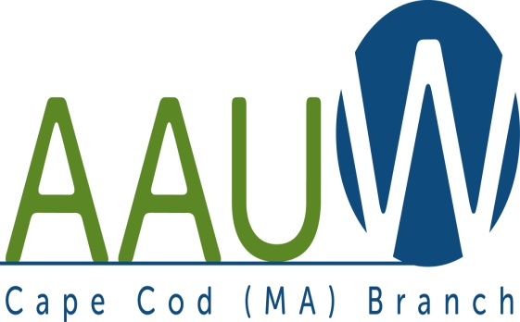 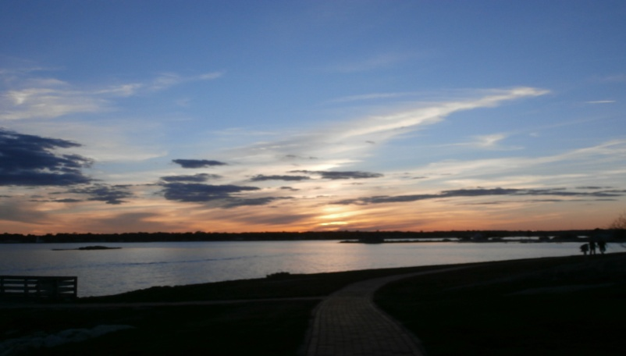

**UNIVERSITY WOMAN AAUW-Cape Cod, Massachusetts Branch, est. 1962 Vol. 41 No.5 February 2015**

**February Meeting Tuesday, February 24th  12:00 p.m. NOON GATHERING AND SOCIAL TIME—LUNCH AT 12:30—SPEAKER AT 1:00**.

**WE HAVE A NEW HOME!!!!! WE WILL BE MEETING AT THE SOUTH YARMOUTH METHODIST CHURCH. IT IS LOCATED AT 322 OLD MAIN STREET, right across from the Hess Gas Station. We will be meeting there for the rest of the year.** The meeting hall is around back. It is spacious enough for us, has a lovely kitchen, space to leave our belongings, decent parking, and handicap access. Parking: in the church lot, first right on Old Main OR Town of Yarmouth public parking--enter on RTE 28, just across from the Riverway. The meeting space can be entered by a walk in the back—A sign will be posted.

**PROGRAM HAVE A HEART- VOLUNTEER**

**We will have a series of speakers from non-profit groups on Cape Cod who will give presentations on their programs and enlist your help in looking for mentors and volunteers. We will have Caroline Corrigan to represent the Council of Churches and Homeless Not Hopeless, Inc., Lisa McNeill will represent Cape Cod Volunteers, Joan Richard from HopeHealth and Dawn Walnut who will represent Habitat for Humanity.**

**Chairs: Marsha Fredericks and Bo Bowen**

**Hostesses:** Elsa Murphy and TBA

**AAUWAAUWAAUWAAAUWAAUWAAUWAAUWAAUWAAUWAAUWAAUWAAUWAAUW**

**BOARD OF DIRECTORS**

**Marsha Fredericks**

President

**Fran Ziegler Sheila Mennell**

Financial Officer Recording Secretary

* **Rebecca Alden Carol Mitchell Judith Needham**

Vice President, Vice President, Vice President,

AAUW Funds Programs Membership

**AAUWAAUWAAUWAAAUWAAUWAAUWAAUWAAUWAAUWAAUWAAUWAAUWAAUW**

**PRESIDENT’S MESSAGE FEBRUARY 2015**

SNOW, SNOW and more SNOW! 2015 has certainly grabbed our attention with the weather. I do hope that those of you who have not fled to warmer climes are staying safe and warm. The February thaw is due and with luck will occur the week of our February meeting. If not, and we are snowed out again, please watch for an email, and check the no school announcements. If the busses cannot navigate the roads, neither can we.

Please take a moment and send Jane Haven a cheery get well. She is a long time and dedicated member of this group and would love to hear from you.

National convention is coming up in June. Please take a look at the AAUW National website and see if this is something in which you would like to participate.

In order for this group to continue and prosper in its present form help is needed from you. Co-chairs for Program VP have been suggested. Is there someone in the group you know and can work with to set up interesting and relevant programs for two years? Please think about it. Our next president should come from the present board. We also need a VP for AAUW funds, which is a relatively easy job. We have changed the day and time of board meetings to 10:30AM on the day of the branch meeting. Please consider a position when a nominating committee member contacts you.

Reminder: Board of Directors meeting is schedules for February 24th at 10:30 A.M.

**AUWAAUWAAUWAAAUWAAUWAAUWAAUWAAUWAAUWAAUWAAUWAAUWAAUW**



**In Memoriam**

**DOROTHY ROBERTS**

**AUWAAUWAAUWAAAUWAAUWAAUWAAUWAAUWAAUWAAUWAAUWAAUWAAUW**

**AAUW – Cape Cod Branch**

**INTEREST GROUPS—NEW AND OLD**

C:\Users\Alice\AppData\Local\Microsoft\Windows\Temporary Internet Files\Content.IE5\9T9R88ZQ\MC900217144[1].wmf

**Pot Luck Dinner Group** Elaine Bono will hostess the next meeting in March. The exact date is yet to be decided, but it will again be a late lunch. Volunteers to bring one dish and/or new members are welcome. For information contact Elsa Murphy at 896-7661 or [elsa.e.murphy@gmail.com](mailto:elsa.e.murphy@gmail.com)

**Cape Cod Theater group** If you are interested in the Cape theater offerings contact Beth Flanagan at bethqf@verizon.net or 508 362-4319 to add your name to her list. Attendance is at your interest and convenience and the group often goes to local restaurants for dinner before or after the theater performances.



Four book groups are still going strong.

**Book Group 1** meets on first Thursday at 1:00 contact Barbara Fletcher

**Book Group 3** meets on third Thursday at 1:00 contact Beverly Stec

**Book Group 7** meets on fourth Monday at 1:30 contact Anne Swanson

**Book Group 9** meets on third Thursday at 1:00 contact Mary Smith



Birthdays Group The next Birthdays lunch will be for Jan. / Feb celebrants. If Pam Berube has not yet contacted you call her at 508 778-6741 for time and date.

C:\Users\Alice\AppData\Local\Microsoft\Windows\Temporary Internet Files\Content.IE5\DMCCHU5I\MC900311636[1].wmf

Book Exchange is intended to be an ongoing activity. Response at first meeting was enthusiastic. If you have books you want to share, bring them to next branch meeting.

**AAUWAAUWAAUWAAAUWAAUWAAUWAAUWAAUWAAUWAAUWAAUWAAUW**

|  |  |
| --- | --- |
| |  | | --- | |  |   March Book Reading  The Faith Club: A Muslim, A Christian A Jew—Three Women Search for Understanding  By Ranya Idliby, Suzanne Oliver, and Priscilla Warner  This is the book the board has chosen for everyone to read by the March meeting so that, as we have done in the past, we will meet earlier in the morning and have a discussion on the book lead by a member of the AAUW Cape Cod Branch. In these times this book is very appropriate as it is about three friends who were from the three religions who after September 11 started out trying to make a picture book for their children about their three religions and it ended up being a memoir of spiritual reflections in three voices which will give us insight into the three religions and give us lots to discuss at the March meeting. Please get a copy at your favorite bookstore, order it if you must, and read it by the March meeting and bring your comments and questions with you.  **AAUWAAUWAAUWAAAUWAAUWAAUWAAUWAAUWAAUWAAUWAAUWAAUW**  ***Envision the Future***  A program for young women ages 11-13  Will be held from July 20 – 24, 2014  At Bridgewater State University  Sponsored by  AAUW, Bridgewater State University, CONNECT Partnership SE MA STEM Network, and  The Office of Congressman Joseph Kennedy  We will be looking for your participation in this program in the future. It will be be the basis of another program duplicated next year for Middle School girls on Cape Cod that we will also be involved with. Much more information to follow.  **AAUWAAUWAAUWAAAUWAAUWAAUWAAUWAAUWAAUWAAUWAAUWAAUW**  It’s time to show off your artistic side in the annual AAUW Art Contest! From now through February 25, AAUW members can [vote once a day](http://listsrv.aauw.org/t/94233/4650974/193/68/) for their six favorite entries. You will need your **member number**. [Each time you vote](http://listsrv.aauw.org/t/94233/4650974/193/69/), you will automatically be entered into a drawing to win one of 10 $25 gift certificates to ShopAAUW. The six winning entries, chosen by your votes, will be featured on a collection of AAUW note cards to be mailed to members this spring. If you haven’t yet become an AAUW member or need to [renew your membership](http://listsrv.aauw.org/t/94233/4650974/2311/70/), now is the perfect time to do so to be able to vote and receive these unique AAUW cards. Remember how excited we were to vote Joan Shostak’s entry in to the AAUW Annual Calendar. Get online now and vote every day. You could win $25!!! Log on at [www.aauw.org](http://www.aauw.org) and vote!!!  **AAUWAAUWAAUWAAAUWAAUWAAUWAAUWAAUWAAUWAAUWAAUWAAUW**  **WINTER AAUW OUTLOOK**  For Barbara Fletcher and Bo Bowen please take note of Frances Perkins on the back cover of this edition of the AAUW OUTLOOK. As it tells you, she was the first woman appointed to a presidential cabinet…she was the Secretary of Labor. Barbara and Bo, and Frances are all proud to be proud Worcesterites!!! Yes, Frances is another AAUW member from Worcester!!!! |

|  |
| --- |
|  |

|  |
| --- |
|  |
|  |