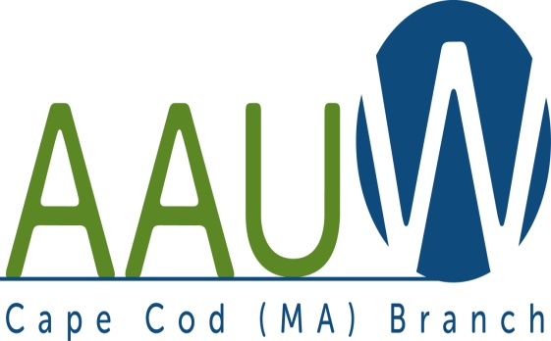 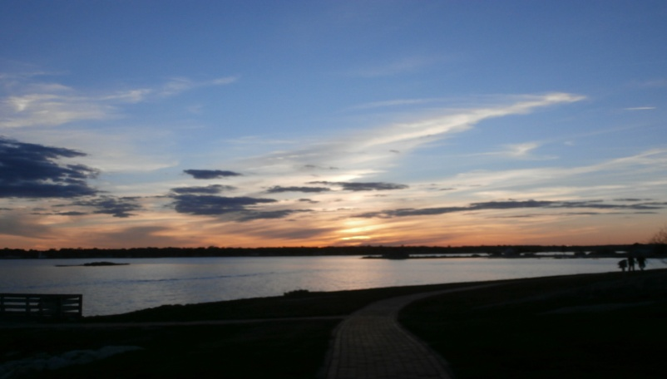

**UNIVERSITY WOMAN AAUW-Cape Cod, Massachusetts Branch, est. 1962 Vol. 41 No.4 January 2015**

**January Meeting Tuesday, January 27th  12:00 p.m. NOON GATHERING AND SOCIAL TIME—LUNCH AT 12:30—SPEAKER AT 1:00**.

**PROGRAM EVERYTHING YOU WANTED TO KNOW ABOUT PILGRIM NUCLEAR, BUT WERE AFRAID TO ASK!!**

Diane Turco is our speaker, and she is a member of the ***Cape Downwinders*** whose mission it is to take action to protect the lives and welfare of the residents of Cape Cod, Martha’s Vineyard and Nantucket against the threat of death or injury resulting from the use of nuclear energy at Pilgrim and other locations.

**We are meeting at THE DENNIS POLICE STATION. Take Exit 9B off of Rt. 6 and the Police Station on the left at the light at the corner of Robert Crowell Road.**

**Chair:** TBA

**Hostesses:** Elsa Murphy and TBA

**AAUWAAUWAAUWAAAUWAAUWAAUWAAUWAAUWAAUWAAUWAAUWAAUWAAUW**

**BOARD OF DIRECTORS**

**Marsha Fredericks**

President

**Fran Ziegler Sheila Mennell**

Financial Officer Recording Secretary

* **Rebecca Alden Carol Mitchell Judith Needham**

Vice President, Vice President, Vice President,

AAUW Funds Programs Membership

**AAUWAAUWAAUWAAAUWAAUWAAUWAAUWAAUWAAUWAAUWAAUWAAUWAAUW**

**Reminder: This is the time we are looking for a new Slate of Officers. Please volunteer, if interested.**

**PRESIDENT’S MESSAGE JANUARY 2015**

Another year begins. We had a lovely holiday luncheon in December at the Hyannis Yacht Club. Thanks go to Diane Bower who arranged the venue and menu and Beth Flanagan who found a wonderful duo who entertained us with a wide variety of holiday music.

Heartfelt thanks go out to all of you who sent cards and get well wishes to me during my recent surgery and recuperation.

Meeting places will decided on a month to month basis. Please check your newsletter monthly for this important information.

We have many upcoming events beyond our monthly meetings. Please check your newsletter and/or our website for details.

The information and applications for NCCWSL, (National Conference for College Women Student Leaders) have been distributed to CCCC and Mass Maritime. The board voted to allot $600.00 each for two young women to attend. The registration fee of $425.00 includes housing for 2 nights, and 5 meals, which include breakfast on the 30th for those who chose to extend their stay. Additional nights, before and after the conference are available at $60.00 per night. Please check the AAUW website for more detailed information AND to see what this is all about. Barbara Fletcher, Lyn Solomon and Marci Applebaum have graciously offered to read the applications and determine successful applicants. One of our requirements for a successful applicant is to attend a meeting and report on her experience.

March is diversity month and we are once again encouraging all members to read and come together at 11am prior to the March branch meeting. We will be reading THE FAITH CLUB by Ranya Idliby, Suzanne Oliver and Priscilla Warner. These three young mothers: a Muslim, a Christian and a Jew came together to discuss and compare their theologies with the hope of better explaining to their children. Please join us at 11am on March 24 for a discussion led by Becky Alden.

Branch officer election time is rapidly approaching. This year we will be electing a president, VP (or CO-VP’S) of programs and VP of AAUW funds. Three branch members (NOT board members) are needed to join two members for the nominating committee. This job does NOT require endless meetings—perhaps one time to sort out true possibilities and establish a calling list. ALSO, every member of the branch is asked to please consider taking one of these officer positions. The term of office is two years and you need not re-up. It has been suggested that vp of programs should be a shared position, please keep that in mind as you consider your involvement. There will also be openings in the appointed positions. Anyone in an appointed position who would like to “retire”, please call or email me to let me know.

**AUWAAUWAAUWAAAUWAAUWAAUWAAUWAAUWAAUWAAUWAAUWAAUWAAUW**

**AAUW – Cape Cod Branch**

**INTEREST GROUPS—NEW AND OLD**

C:\Users\Alice\AppData\Local\Microsoft\Windows\Temporary Internet Files\Content.IE5\9T9R88ZQ\MC900217144[1].wmf

**Cape Cod Theater group** If you are interested in the Cape theater offerings contact Beth Flanagan at bethqf@verizon.net or 508 362-4319 to add your name to her list. Attendance is at your interest and convenience and the group often goes to local restaurants for dinner before or after the theater performances.



Four book groups are still going strong.

**Book Group 1** meets on first Thursday at 1:00 contact Barbara Fletcher

**Book Group 3** meets on third Thursday at 1:00 contact Beverly Stec

**Book Group 7** meets on fourth Monday at 1:30 contact Anne Swanson

**Book Group 9** meets on third Thursday at 1:00 contact Mary Smith



|  |  |  |
| --- | --- | --- |
| **Birthdays Group** The next Birthdays lunch will be for Jan. / Feb celebrants. If Pam Berube has not yet contacted you call her at 508 778-6741 for time and date.  C:\Users\Alice\AppData\Local\Microsoft\Windows\Temporary Internet Files\Content.IE5\DMCCHU5I\MC900311636[1].wmf  **Book** E**xchange** is intended to be an ongoing activity. Response at first meeting was enthusiastic. If you have books you want to share, bring them to next branch meeting.    **AAUWAAUWAAUWAAAUWAAUWAAUWAAUWAAUWAAUWAAUWAAUWAAUW**   |  | | --- | | Special Announcement |      |  | | --- | | March Book Reading  The Faith Club: A Muslim, A Christian A Jew—Three Women Search for Understanding  By  Ranya Idliby, Suzanne Oliver, and Priscilla Warner  This is the book the board has chosen for everyone to read by the March meeting so that, as we have done in the past, we will meet earlier in the morning and have a discussion on the book lead by a member of the AAUW Cape Cod Branch. In these times this book is very appropriate as it is about three friends who were from the three religions who after September 11 started out trying to make a picture book for their children about their three religions and it ended up being a memoir of spiritual reflections in three voices which will give us insight into the three religions and give us lots to discuss at the March meeting. Please get a copy at your favorite bookstore, order it if you must, and read it by the March meeting and bring your comments and questions with you.  **AAUWAAUWAAUWAAAUWAAUWAAUWAAUWAAUWAAUWAAUWAAUWAAUW**  ***Envision the Future***  A program for young women ages 11-13  Will be held from July 20 – 24, 2014  At Bridgewater State University  Sponsored by  AAUW, Bridgewater State University, CONNECT Partnership SE MA STEM Network, and  The Office of Congressman Joseph Kennedy  We will be looking for your participation in this program in the future. It will be be the basis of another program duplicated next year for Middle School girls on Cape Cod that we will also be involved with. Much more information to follow.  **AAUWAAUWAAUWAAAUWAAUWAAUWAAUWAAUWAAUWAAUWAAUWAAUW**  HAPPY NEW YEAR TO ONE AND ALL! | |

|  |
| --- |
|  |
|  |