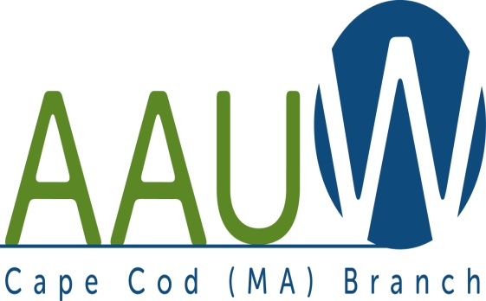 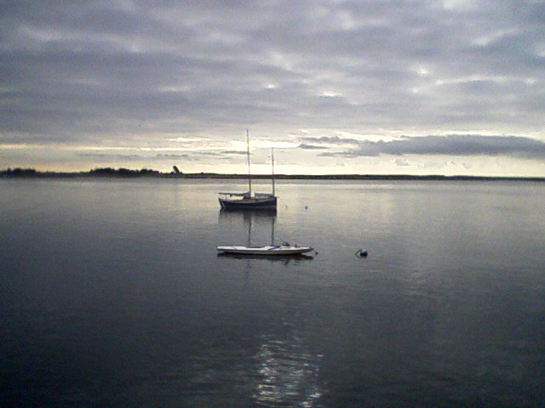

**UNIVERSITY WOMAN AAUW-Cape Cod, Massachusetts Branch, est. 1962 Vol. 41 No.3 November 2014**

**November Meeting Tuesday, November 18th  12:00 p.m. NOON GATHERING AND SOCIAL TIME—LUNCH AT 12:30—SPEAKER AT 1:00**. **WE ARE NOT MEETING AT ST. DAVID’S.**

**We are meeting at a new place!!!! THE NOVEMBER MEETING WILL BE HELD AT THE DENNIS POLICE STATION. Take Exit 9B off of Rt. 6 and the Police Station on the left at the light at the corner of Robert Crowell Road. As Marsha explained in her President’s Message last month, we are trying out new venues to find a permanent home.**

**PROGRAM: DAVID (V) GOLIATH**

Two young women driven by the concept that authors should receive more equitable compensation for their work, tackle Amazon and the giant publishers by opening a small independent publishing house in the Berkshires.

**Chair:** Carol Mitchell

**Hostesses:** Barbara Mulligan-Rado and Beverly Stec

**AAUWAAUWAAUWAAAUWAAUWAAUWAAUWAAUWAAUWAAUWAAUWAAUWAAUW**

**BOARD OF DIRECTORS**

**Marsha Fredericks**

President

**Fran Ziegler Sheila Mennell**

Financial Officer Recording Secretary

* **Rebecca Alden Carol Mitchell Judith Needham**

Vice President, Vice President, Vice President,

AAUW Funds Programs Membership

**AAUWAAUWAAUWAAAUWAAUWAAUWAAUWAAUWAAUWAAUWAAUWAAUWAAUW**

**PRESIDENT’S MESSAGE NOVEMBER 2014**

The President herself has become the topic of this article…not the author. Ms. Marsha has had her appendix out last week and is resting comfortably at home. This caused her to cancel her long awaited AAUW sponsored trip to Poland and for that she is disappointed but glad she was smart enough to get to go to the hospital here and not be up in the plane or in Poland when the appendix might have ruptured. She will now be taking the touring time to recoup at home in her own home and in her own bed.

**AUWAAUWAAUWAAAUWAAUWAAUWAAUWAAUWAAUWAAUWAAUWAAUWAAUW**

**AAUW – Cape Cod Branch**

**INTEREST GROUPS—NEW AND OLD**

C:\Users\Alice\AppData\Local\Microsoft\Windows\Temporary Internet Files\Content.IE5\9T9R88ZQ\MC900217144[1].wmf

**Cape Cod Theater group** enjoyed both musicals and dramas this summer. They are looking forward to seeing Funny Girl in November. If you are interested in the Cape theater offerings contact Beth Flanagan at bethqf@verizon.net or 508 362-4319 to add your name to her list. Attendance is at your interest and convenience and the group often goes to local restaurants for dinner before or after the theater performances.



Four book groups are still going strong.

**Book Group 1** meets on first Thursday at 1:00 contact Barbara Fletcher

**Book Group 3** meets on third Thursday at 1:00 contact Beverly Stec

**Book Group 7** meets on fourth Monday at 1:30 contact Anne Swanson

**Book Group 9** meets on third Thursday at 1:00 contact Mary Smith



|  |  |  |
| --- | --- | --- |
| **Birthdays Group** which meets bimonthly to celebrate those members whose birthdays fall in Sept./Oct., Nov./Dec., Jan./Feb., Mar./Apr., or May/June with dinner or lunch at a local restaurant. Pam Berube is the coordinator for the group. Contact her at pberube@comcast.net or 508 778-6741 if your birthday is in November or December or if you want to join the fun.  C:\Users\Alice\AppData\Local\Microsoft\Windows\Temporary Internet Files\Content.IE5\DMCCHU5I\MC900311636[1].wmf  NEW this year is a proposed **Pot Luck Dinner group** for those of us who like to dine but find that cooking for one in not much fun. If you are interested send me your name at elsa.e.murphy@gmail.com or 508 896-7661. Let’s meet at 11:45 before the November branch meeting to discuss a date.  **AAUWAAUWAAUWAAAUWAAUWAAUWAAUWAAUWAAUWAAUWAAUWAAUW**   |  | | --- | | Special Announcement |      |  | | --- | | March Book Reading  The Faith Club: A Muslim, A Christian A Jew—Three Women Search for Understanding  By  Ranya Idliby, Suzanne Oliver, and Priscilla Warner  This is the book the board has chosen for everyone to read by the March meeting so that, as we have done in the past, we will meet earlier in the morning and have a discussion on the book lead by a member of the AAUW Cape Cod Branch. In these times this book is very appropriate as it is about three friends who were from the three religions who after September 11 started out trying to make a picture book for their children about their three religions and it ended up being a memoir of spiritual reflections in three voices which will give us insight into the three religions and give us lots to discuss at the March meeting. Please get a copy at your favorite bookstore, order it if you must, and read it by the March meeting and bring your comments and questions with you.  **AAUWAAUWAAUWAAAUWAAUWAAUWAAUWAAUWAAUWAAUWAAUWAAUW**  ***Envision the Future***  A program for young women ages 11-13  Will be held from July 20 – 24, 2014  At Bridgewater State University  Sponsored by  AAUW, Bridgewater State University, CONNECT Partnership SE MA STEM Network, and  The Office of Congressman Joseph Kennedy  We will be looking for your participation in this program in the future. It will be be the basis of another program duplicated next year for Middle School girls on Cape Cod that we will also be involved with. Much more information to follow.  **AAUWAAUWAAUWAAAUWAAUWAAUWAAUWAAUWAAUWAAUWAAUWAAUWAAUW**  **Yearbook Changes**  **Maria Chatzinakis**  BA Hofstra  MS CW Post LIU  **Peg Belden**  10 Portico Way  Plymouth, MA 02360  774-343-5145  A A U W / CAPE COD  “COUNT YOUR BLESSINGS”  to benefit our local AAUW branch & LAF  At my last birthday, I turned ______________@ 10⊄ per year $________________  I have been married _____________years @ 5⊄ per year $________________  I have ____________children @ $1.00 per child $_______________  I have ____________grandchildren @ $1.00 per child $________________  I have ____________great grandchildren @ 50⊄ per child $________________  I have ____________brothers @ 75⊄ each $________________  I have ____________sisters @ 75⊄ each $________________  I have ____________cars @ $1.00 each $________________  I have ____________house/condo/apartment @ $1.00 each $________________  I have ____________computers @ $1.00 each $________________  I have ____________dogs @ 50⊄ each $________________  I have ___________cats @ 50⊄ each $________________  I have ___________masters degree @$1.00 each $________________  I have ___________doctoral degree @ $1.00 $________________  I have ___________other blessings @ 25 ⊄ each $________________  TOTAL $______________  Please count your blessings and mail the bottom part of the form together with your check made payable to ***AAUW/Cape Cod*** by Monday, November 23 (or bring to the November 18th meeting)  to: **Fran Ziegler, 1378 Bumps River Rd., Centerville, MA 02632**  Name___________________________________________ Telephone _________________  Address_______________________________________________________________________  PLEASE PRINT THIS FORM AND RETURN JUST THE BOTTOM WITH YOUR CHECK.  TOTAL ENCLOSED $________  **2014 Helen Storrow Heritage Award**  **Given at the Girl Scout Alumnae Luncheon to Prim Craven and two other Girl Scout Women**    **Primrose “Prim” Craven, Chatham (1920-2012)**  From the time Prim Craven and her young family arrived on Cape Cod in 1963, Prim Craven was actively involved in Girl Scouts and many other civic and charitable organizations in the area. She would go on to become the first Curator of the Girl Scout Museum for Plymouth Bay Girl Scout Council, the first council-owned museum of its kind in the country. The museum was located at the council headquarters in Hough House in Taunton, named in honor of Girl Scout alumna Dorris Hough. As Curator, Prim created and maintained the collection which included uniforms throughout the years, as well as pins and accessories. She collaborated with another dedicated volunteer, Rose Aleixo, to compile an extensive book collection that was also part of the collection. During her long Girl Scout career, Prim also served on the Plymouth Bay Council Board of Directors as a volunteer and worked as a professional with the Girl Scouts of Southeastern Massachusetts as Field Director and Director of Adult Education. By the time the council offices moved to Middleboro in 2000, Prim had retired and focused her attention on the local girls in her area. She was an active service unit volunteer in Chatham, earning her 60-year pin and serving Girl Scouts on the Cape until her death in 2012. In retirement, Prim never missed the Southeastern Massachusetts Alumnae group meetings held in Mattapoisett, catching a ride from the Cape as she loved the camaraderie of her Girl Scout pioneer friends and the stories they told of days gone by. Prim's veins ran green blood and she was a true example of an “Angel in Green.” Southeastern Massachusetts Girl Scout alumna, Sonya Howland of Taunton and Dennis, accepted the award in memory of her friend and colleague.  Southeastern Massachusetts Girl Scout alumna, Sonya Howland of Taunton  **AAUWAAUWAAUWAAAUWAAUWAAUWAAUWAAUWAAUWAAUWAAUWAAUWAAUW** | |

|  |
| --- |
|  |
|  |