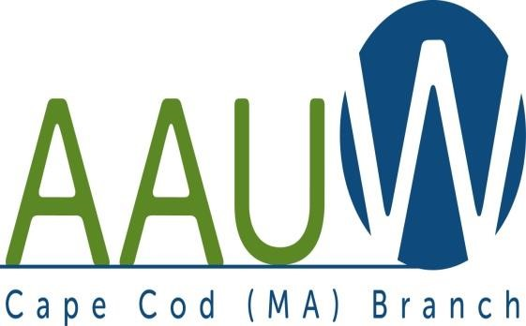 **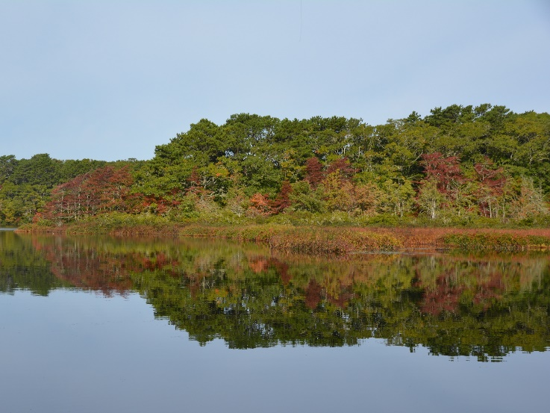**

**UNIVERSITY WOMAN AAUW-Cape Cod, Massachusetts Branch, est. 1962 Vol. 43 No.3 November 2016**

**CHANGE OF DATE -- PLEASE NOTE!**

Tuesday November 29, 2016 (AFTER Thanksgiving!)

12:00 Noon Social hour -- 12:30 light lunch

1:00 pm Speaker and business meeting

How many of **Our National Parks** have you had the opportunity to visit? Come to the November meeting on the 29th and hear Bill Burke, park historian, give a brief history of our national parks and especially the Cape Cod National Seashore. We will also hear from Leslie Reynolds, Chief Ranger at CCNS, and National Park Ranger of the year. Pat Canavan, President of Friends of the Seashore will round out the program with a look at what volunteers can and do accomplish at the Seashore. Don’t miss this informative meeting about the national treasure right in our backyard.

**REMEMBER TO BRING THOSE BOOKS FOR THE EXCHANGE**! This is a perfect time to stock up on fall/winter reading. Members bring books they are finished with (and are willing to part with)—we offer them for $1.00. Bring books, find books.

A summary of future programs follows:

**Becky Alden**: President **Marsha Fredericks**: VP Programs **Barbara Mulligan Rado**

**Phillis Koppel:** Secretary **Carol Carbaugh**: Financial Officer **Elsa** **Murphy:** VPs Membership

**Phyllis Bradley:** VP AAUW Funds

·

**AAUW Programs 2016-2017**

November 29, 2016 -- Cape Cod National Seashore from three perspectives—Bill Burke, Park Historian, Leslie Reynolds, Chief Ranger and Pat Canavan, President of Friends of the Seashore.

December 13, 2016 -- Annual Holiday Luncheon

January 24, 2017 -- Dr. Stephanie Weaver, Director of Cape Cod Conservatory

February 28, 2017 -- Meredith Baier, Cape Cod Path (People Against Trafficking in Humans)

March 28, 2017 --Diversity Month -- Book discussion “Waking Up White” by Debbie Irving Discussion and program led by Becky Alden Please watch for start time and further information in the monthly bulletin.

April 25, 2016 --Alice Plouchard Stelzer presents “Mehetable”, an adventurous woman who helped to settle New England.

May 9, 2017 -- Annual Luncheon and Installation of Officers

*AAUWAAUWAAUWAAUWAAUWAAUWAAUWAAUWAAUWAAUWAAUWAAUWAAUWAAUWAAUWAAUW*

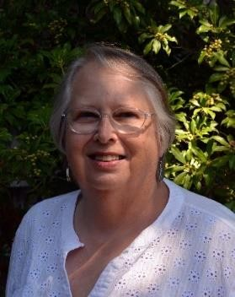**President’s Message:**

*Dear Ladies,  
   The weather is beautiful today, voting day, so you know how late I am in writing this. Lyn Solomon, however is very patient, and I really appreciate that.  
   I hope to see you after Thanksgiving, on November 29 for our November meeting. We will have our usual Board Meeting beginning at 10:30 with the program/meeting beginning around 12:30. Our sandwiches, dessert, coffee/tea will start around twelve. All Board Meetings are open, so if you would like to join us, please just show up. If you have something to discuss, please sent me an email, so I can put you on the agenda.  
   Please remember to bring a book or two to the meeting.  
   Our Holiday Luncheon is set for****Thursday, December 15****. More information and sign-up sheet is at the end of this newsletter. It's a great time to invite a guest who may be interested in joining us.  
   Our book this year is Waking Up White by Debby Irving. Our usually March discussion will be about the book plus a one or two exercises about Racial Justice. If anyone would like to join me in the planning for this meeting, please let me know.  
   See you on the 29th.*

*Becky Alden, President*

*AAUWAAUWAAUWAAUWAAUWAAUWAAUWAAUWAAUWAAUWAAUWAAUWAAUWAAUWAAUWAAUW*

**Membership News**

Yes the Membership Booklets will be available at the November meeting

*AAUWAAUWAAUWAAUWAAUWAAUWAAUWAAUWAAUWAAUWAAUWAAUWAAUWAAUWAAUWAAUW*

**STUDY AND INTEREST GROUP NEWS**

**BIRTHDAY GROUP**meets bi-monthly to celebrate members’ birthdays with lunch at local restaurants and to share interests, memories, and opinions.  A new contact is needed to coordinate this group.  Call Elsa Murphy  [508 896-7661](tel:508%20896-7661" \t "_blank) or [elsa.e.murphy@gmai.com](mailto:elsa.e.murphy@gmai.com) if you are willing call celebrants and select restaurants.

**C:\Users\Alice\AppData\Local\Microsoft\Windows\Temporary Internet Files\Content.IE5\9T9R88ZQ\MC900217144[1].wmfCAPE COD THEATER** travels the Cape to see local theater productions. A list of possibilities is offered and members attend based on their interest.  The group generally goes to dinner as well.  Contact ; Beth Flanagan  [508 363-4319](tel:508%20363-4319) or [bethqf@verizon.net](mailto:bethqf@verizon.net).

**FIIM GROUP** meets to discuss current films at Brewster Ladies Library at 10:30 on 3rdWednesday. Film for November is **Hacksaw Ridge**.  It is playing many places now and beginning Friday.  See it at your convenience and join us for discussion on Oct. 19th. Contact : Phyllis Koppel [508 237-3169](tel:508%20237-3169) oro[phylliskoppel@comc.net](mailto:phylliskoppel@comc.net).

**COOPERATIVE DINNERS GROUP** is a group of members most of whom live alone and meet to enjoy prepared meals .  Everyone contributes some part of the dinner and they meet at homes of members who have generous dinner tables.  The **November Cooperative dinner** will be held on **Monday, Nov. 14, at 2:00** pm.  Barbara Mulligan-Rado,  is the hostess.  RSVP with your contribution to Elsa Murphy.  For directions contact Barbara.

**BOOK GROUPS** meet at members homes to discuss books of their choosing.  There are three groups active currently.

**Book Group** 1 meets  the 1st Thursday at 10:30 a.m. in the Falmouth area. Contact : Barbara Fletcher [508 540-2758](tel:508%20540-2758)

**Book Group  3** meets the 3rd Thursday at 1:00 p.m. in the mid-Cape area.

Contact : Barbara Mulligan-Rado [508 398-0647](tel:508%20398-0647) or [bmrado@comcast.net](mailto:bmrado@comcast.net).

**Book Group 7** meets the 4th Monday at 1:30 p.m. in mid-Cape area

Contact : Anne Swanson  [508 428-0914](tel:508%20428-0914) or [goranne@comcast.net](mailto:goranne@comcast.net)

**