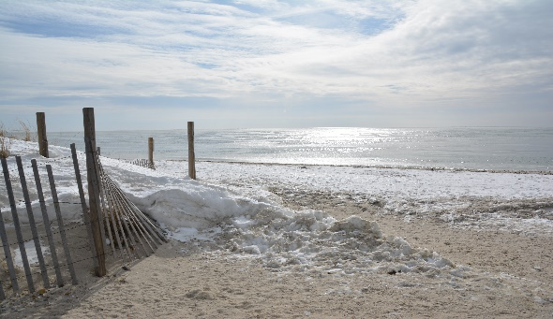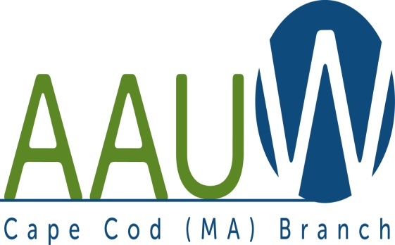

**UNIVERSITY WOMAN AAUW-Cape Cod, Massachusetts Branch, est. 1962 Vol. 42 No.4 January 2016**

**January Meeting: *Please Note Change of Program and Location***

**Date:** TUESDAY JANUARY 26, 2016 12:00 NOON

**Meeting Location:** ZION UNION HERITAGE MUSEUM; 276 NORTH STREET HYANNIS, MA

The mission of the Zion Union Heritage Museum is to create and maintain a facility that celebrates especially the African American and Cape Verdean contributions to the Town of Barnstable and Cape Cod. ( And here you thought that Cape Cod has been settled and peopled only by the Eldrigdes, the Crowells and the Aldens.) Please join us for an informative talk by Mr. John Reed, President of the Board of Directors of the Zion Union Heritage Museum. We will meet in the CHAPEL at 12:00 NOON for an introduction to the museum and a quick walk through. We will adjourn to the meeting room for our usual light lunch and business meeting. This will be followed by brief presentation by one or more of the resident artists, Carl Lopes, Liz Mumford and Pamela Chatterton Purdy, and time to explore the museum at leisure.North Street runs parallel to Main Street. Parking is limited: please carpool if you can. Check the museum out at zionunionheritagemuseum.org.

**TITLE IX**  -- Thank you to all the members who graciously volunteered to take the TITLE IX materials and approach the Superintendent and Title IX coordinator for their town. We have heard from several members that they have successfully met with and delivered the AAUW/ Dept of Education/Office of Civil Rights materials. If you have not been able to connect yet, please do not forget! January is a quieter time for schools.

**Jewelry Sale:** We are still collecting jewelry for the March indoor yard sale in Yarmouth. I will be contacting those who offered to clean, sort and price in January. I propose the proceeds from this sale be applied to the Greta Tomic and Friends Scholarship Fund. If you want to help, please email me at [busywomancc@comcast.net](mailto:busywomancc@comcast.net).

Thanks, Marsha (508-694-6279)

***AAUWAAUWAAUWAAAUWAAUWAAUWAAUWAAUWAAUWAAUWAAUWAAUWAAUW***

**BOARD OF DIRECTORS**

**Becky Alden**

President

**Fran Ziegler Sheila Mennell**

Financial Officer Recording and Correspondence Secretary

* **Phyllis Bradley Marsha Fredericks Judith Needham**

Vice President, Vice President, Vice President,

AAUW Funds Programs Membership

***NCCWSL -*** The applications for the Greta Tomic and Friends scholarship to nccwsl have been distributed to CCCC and MMA. Registration opens earlier this year. The branch need 2-3 people WHO ARE NOT ON THE BOARD to collect, read the apps and make a decision. This is a short term, once a year position. Please help. Contact Becky at [raalden@capecod.net](mailto:raalden@capecod.net). Thank you!!

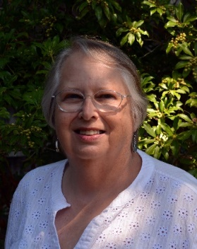**PRESIDENT’S MESSAGE: 12/31/2015**

January, 2016

Happy New Year! I am excited about beginning this new calendar year, and I hope that you are, too.

First, I know that Marsha has a great program set for us this month. Please see her message about where we will be meeting. I have known John Reed, our host, for many years – since my teaching days in the Harwich School System. I expect it to be a great day. Please plan on attending if you can.

There are several other events occurring the next few months which I hope that you will put on your calendar and plan to attend. The Cape Women’s Coalition is again sponsoring the International Women’s Breakfast on March 4th in Hyannis from seven-fifteen to ten. Last year we almost got “snowed-out” and I couldn’t get out of my house, but Marsha was able to attend. It should be a great program this year, too.

Equal Pay Day this year is Tuesday, April 12. On a recent AAUW conference call, several suggestions for events were made. One that interested me was an “Unequal Bake Sale” where women get a 21% discount, but men had to pay full price. Doesn’t that sound like fun? Interesting, but sad to note, are other “Equal Pay Days” – August 26th for women of color, September 14 for women who are Native Americans, and October 15 for Hispanic women.

Our state AAUW Convention will be in Boston on May 7 at the Harvard School of Public Health. The Boston Branch will be our host. Please put this on your calendar. We can carpool there. More about this later.

Again, I am looking forward to seeing you in January at the Zion Museum

*Becky Alden, President*

***AAUWAAUWAAUWAAAUWAAUWAAUWAAUWAAUWAAUWAAUWAAUWAAUWAAUW***

**AAUW CAPE COD BRANCH BOARD MEETING: NOVEMBER 17, 2015**

In attendance: Fran Zeigler; Sheila Mennell; Beverly Stec; Becky Alden; Carol Carbough; Judy Needham; Donna Traska; BethFlanagan; Phyllis Bradley; Elsa Murphy; Lyn Solomon; Alice Bowen; Marsha Fredericks; Julie Gideonse.

Reports of recording secretary and treasurer accepted as presented.

Membership: Judy Needham informed that former president Lillian Batchelder had passed away. She sent reminders to 2 unpaid members and had gotten one back, so was only one outstanding.

Programs: Marsha reported that all was on track with Mollie Lamb from National speaking to us today on Title IX. Brenda Collins will now be doing her presentation in February and Marsha was trying for our visit to Zion for January. NCWSL registration begins in December and ends Feb. 2nd for meetings at the 4 C's and Mass Maritime. Marsha will contact school systems who read 'I Am Malala" to invite to hear our March speakers. She also suggested a New Member luncheon and open house be held in June or next Sept. and invite the public to learn about the organization. Need to recruit new members is high. Will market organization with cards to hand out and leave a places like libraries, senior centers. Discussed ideas for type of luncheon, with Becky suggesting combine with March meeting when new members joining get to pay half dues. Also reminded about donating jewelry for sale.

AAUW Funds: Phyllis Bradley reported was to keep track of AAUW funds from 'Count Your Blessings' and get a list from Nation of donations with the idea of writing thank you notes to donors.

Newsletter: Since there is no December meeting, only a holiday luncheon, there will be no newsletter.

Public Information: Beth Flanagan sent out notices for this meeting as with others to usual sources including Wendy Lapata at the Cape Cod Times.

Hospitality: Julie says hostesses are needed for a number of meetings; also, if no school meeting will be cancelled.

Interest Groups: Beth Flanagan told about the theater group and Phyllis Koppel and Lyn Solomon told about movie group and meeting date of 3rd Wed. of each month at 10:30 Brewster Ladies Library.

Cape Women's Coalition representative will continue to be Becky. Elaine Bono attended last dinner with her.

Reminded of Holiday Luncheon December 8 at King's Way restaurant.

Respectfully submitted, Sheila Mennell Recording Secretary

***AAUWAAUWAAUWAAAUWAAUWAAUWAAUWAAUWAAUWAAUWAAUWAAUWAAUW***

**MEMBERSHIP**

**Here is a listing of our newest members. Welcome!**

Patricia BUSH  
1580 Main Street  
Brewster, MA 02631  
[508-241-6410](tel:508-241-6410)  
Bittersweetcapecod@ [hotmail.com](http://hotmail.com/)  
BA Nazareth College  
  
Sandra E. LOCKE  
13 Whiting Street, #1  
Plymouth, MA 02360  
[508-927-4540](tel:508-927-4540)  
[Nanalock@gmail.com](mailto:Nanalock@gmail.com)  
UMASS

Antonia MARTIN  
21 Taylor Bray Farm Road North  
Yarmouth Port, MA 02675  
[508-385-9821](tel:508-385-9821)  
[516-902-0323](tel:516-902-0323) cell  
[Martinm@juno.com](mailto:Martinm@juno.com)  
MS FORDHAM  
MS ADELPHI  
  
Patricia A. RYLE  
P.O. Box 13  
West Dennis, MA 02620  
[781-689-5402](tel:781-689-5402)  
[Patr1111@hotmail.com](mailto:Patr1111@hotmail.com)  
BS BRIDGEWATER STATE  
MS LESLEY UNIV

**Memoriam:**  
Lillian Batchelder, Honorary Life Member and Past President



*And*

Dr. Beth M. Stiffler, Honorary Life Member

Also:  Marjorie Worrell lost her husband, Francis T. Worrell in December

***AAUWAAUWAAUWAAAUWAAUWAAUWAAUWAAUWAAUWAAUWAAUWAAUWAAUW***

**AAUW – Cape Cod Branch**

**STUDY AND INTEREST GROUP NEWS**

The response to the request for donation to the Book Exchange resulted in a good selection of titles.  Keep bringing books you want to share to each branch meeting.  The small price of one dollar a book adds to our funds and your reading pleasure.  If the books you bring do not sell, please pick them up at the end of the meeting.  We cannot store extra donations.

**Film Discussion Group:** We met in November and December to discuss “Suffragette” and “Brooklyn”. Our discussions are lively and informative. For our “Brooklyn” discussion we each told a story of our own family heritage. Our next film will be “The Danish Girl” coming out in theaters in January. If anyone would like to join us we will be meeting Wed. January 20th at 10:30 at the Brewster Ladies Library. Those who choose to have been going to Ardeos afterwards for lunch.  Other questions, please email Phyllis at [phylliskoppel@comcast.net](mailto:phylliskoppel@comcast.net)

C:\Users\Alice\AppData\Local\Microsoft\Windows\Temporary Internet Files\Content.IE5\9T9R88ZQ\MC900217144[1].wmfThe **Theater Group**: We are waiting for some new productions.



**Our bi-monthly Birthday Celebrations** will start again shortly. Pam Berube will be contacting you if your birthday falls in January and February.

**Cooperative potluck dinners** The Cooperative Dinners will be held at lunchtime (1:00 p.m.) during the dark winter months.  January date will be sent  to members by email.  We welcome newcomers.  For more information contact Elsa Murphy 896-7661 or [elsa.e.murphy@gmail.com](mailto:elsa.e.murphy@gmail.com).

**BOOK GROUPS**

Book Group 1 meets on the 1st Thursday.  Contact Barbara Fletcher (540-2758) for more information.

Book Group 3 meets on 3rd Thursday. Contact Barbara Bracken (362-6195 or [bjsjb@comcast.net](mailto:bjsjb@comcast.net))  for more information.

 Book Group 7 meets on 4th Monday.  Contact Anne Swanson (428-0914 or [goranne@comcast.net](mailto:goranne@comcast.net)) for more information.