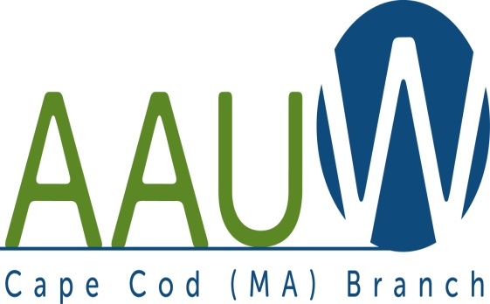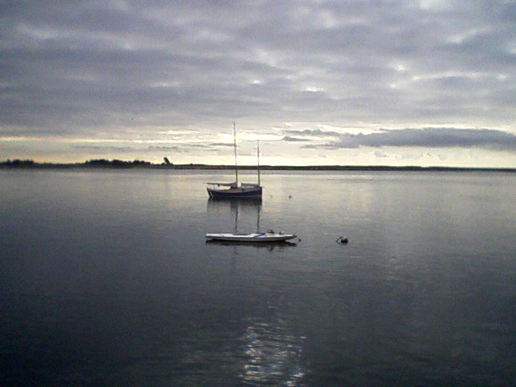
UNIVERSITY WOMAN AAUW-Cape Cod, Massachusetts Branch, est. 1962 Vol. 41 No.1 September 2014

September Meeting Tuesday, September 23rd at 12:15 p.m.
Nelson Hall, St. David’s Church, 205 Old Main St., Yarmouth, MA
The American Association of University Women (AAUW) is building a better future for women and girls. Meet some of the most interesting women on Cape Cod while learning how AAUW is fostering women candidates, building girls’ science skills through Tech Trek programs, and providing scholarships to women returning to college.
Please join us on Tuesday, September 23rd at 12:00 at Saint David’s Church Hall in South Yarmouth for a celebration of AAUW’s members, its programs, and its dedication to gender equality.
Artists and Artisans
Cape Cod has long provided artists and artisans with inspiration for their work.
Pamela Parker from Harvest of Barnstable will demonstrate how to make a wreath from a variety of dried flowers available from Harvest. Elizabeth Hogan will display her work.
Chair: Marsha Fredericks
Hostesses: Rebecca Alden and Carol Carbaugh

AAUWAAUWAAUWAAAUWAAUWAAUWAAUWAAUWAAUWAAUWAAUWAAUWAAUW
BOARD OF DIRECTORS
Marsha Fredericks
President
Fran Ziegler Sheila Mennell
Financial Officer Recording Secretary
- Rebecca Alden Carol Mitchell Judith Needham
Vice President, Vice President, Vice President,
AAUW Funds Programs Membership
AAUWAAUWAAUWAAAUWAAUWAAUWAAUWAAUWAAUWAAUWAAUWAAUWAAUW
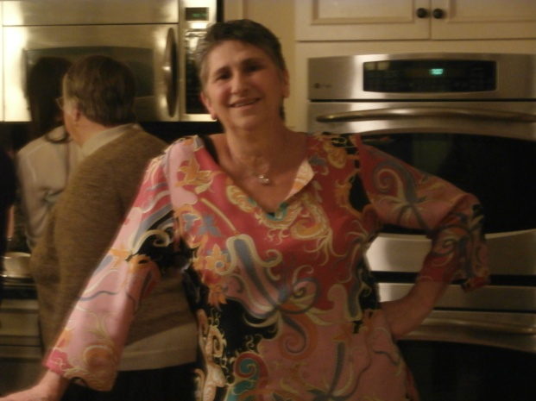
PRESIDENT’S MESSAGE SEPTEMBER 2014
September has arrived and with it shorter days, cooler evenings and the resumption of AAUW Cape Cod monthly branch meetings.
Your program VP, Carol Mitchell has put together a schedule of varied topics and speakers. Be sure to check your newsletter each month for detailed info on the program of the month. Please do invite any friend you feel would enjoy the presentation.
Carol Carbaugh and Beverly Stec have been working diligently on your 2014-15 yearbooks. It has been brought to the printer for formatting and a first limited run for proofreading. It should be in your hands NO LATER THAN the October meeting. Please be sure to thank Carol and Bev for their hard work.
Check out the interest group section! We will be starting a new group—pot luck meals and will continue with birthday month lunch/dinners!
We now have two college/university partners, 4C’s and Mass Maritime, brought into the fold by the Cape Cod branch. The next step is to be visible on campus with programming and opportunities for the students. Ideally we can help establish a student affiliate group. Do you have an interest in this? Let me know!
Your “Greta Tomic Fund” committee met and recommended that the money be used to fund two girls per year to NCCWSL. The board concurred and we are in the process of getting a letter to administrators and application forms to both colleges. This year we will review the applicants ourselves and perhaps interview if needed. The application form is one page and very straight forward. If you would be interested in this short term, limited time committee position, please contact me.
I look forward to seeing you all at our first meeting on Tuesday September 23. Gathering and social time is 12:00-12:30. Light lunch and business meeting begins at 12:30, and our programming begins at 1:00. Please remember to offer your skills as a hostess for one month and/or offer to bring sandwiches or dessert. Kay Campos, your hospitality chair appreciates your involvement!
Any questions or comments, you know where to find me! Marsha
AAUWAAUWAAUWAAAUWAAUWAAUWAAUWAAUWAAUWAAUWAAUWAAUWAAUW

Public Policy
AAUW continues the commitment to equality for women and girls with its programs to encourage women to vote in the 2014 mid-term elections. Voting for candidates who understand how issues affect women is an important part of the process to insure equality whether it is an issue of equal pay, military abuse of power in sexual assault cases, or funding of women's athletic programs on a par with those of men.
AAUW also demonstrated its concern for women in voicing its displeasure with the Hobby Lobby decision of the Supreme Court. This decision means that a woman's access to contraceptives can be restricted by her employer. By rejecting this coverage as part of a health care plan, an employer of a closely held corporation is entitled to refuse to provide coverage under the Affordable Care Act for birth control devices on the grounds of religious objection.
Sexual assault on college campuses is a continuing concern. AAUW works to insure that all students know their rights and all colleges know their responsibilities in this area.
Of concern to both women and men is the 2010 Citizen's United decision of the Supreme Court which effectively deemed that corporations were persons. Among the ramifications of this decision were the removal of restrictions on campaign contributions by unions and big business. They are now permitted to spend huge amounts of money to support or defeat candidates. The influx of huge amounts of money into this year's political foray is already obvious.
On September 8th the US Senate is scheduled to hold a vote whose goal is to eventually override the Citizens United decision. In order for a Supreme Court decision to be negated, a Constitutional amendment must be passed. Both houses of Congress must pass such legislation by a two thirds majority.
Fifty US Senators have already agreed to support this legislation, and it is incumbent upon them to be present for this vote on September 8th even with the election only two months away.
Barbara Mulligan- Rado
Public Policy Chair
AAUWAAUWAAUWAAAUWAAUWAAUWAAUWAAUWAAUWAAUWAAUWAAUWAAUW

Hospitality Notes from Klara Campos

Hospitality is ready and willing to try to make our meetings more pleasant and enjoyable. In September Hostesses: Becky Alden and Carol Carbaugh will be serving coffee and tea. Various "Goodies” on the luncheon table will be available from those that have signed up on the September Sheet. I will Email everyone involved a few days before each meeting to remind them of their participation.
I am always available for suggestions.

Klara Campos (Kay)
AAUWAAUWAAUWAAAUWAAUWAAUWAAUWAAUWAAUWAAUWAAUWAAUWAAUW

AAUW – Cape Cod Branch
INTEREST GROUPS—NEW AND OLD
Those interest groups that did not continue through the summer will be picking up again in the fall.
Cape Cod Theater group enjoyed both musicals and dramas this summer. They are looking forward to seeing Good People in October and Funny Girl in November. If you are interested in the Cape theater offerings contact Beth Flanagan at bethqf@verizon.net or 508 362-4319 to add your name to her list. Attendance is at your interest and convenience and the group often goes to local restaurants for dinner before or after the theater performances.
Four book groups are still going strong.
Book Group 1 meets on first Thursday at 1:00 contact Barbara Fletcher
Book Group 3 meets on third Thursday at 1:00 contact Beverly Stec
Book Group 7 meets on fourth Monday at 1:30 contact Anne Swanson
Book Group 9 meets on third Thursday at 1:00 contact Mary Smith
Birthdays Group which meets bimonthly to celebrate those members whose birthdays fall in Sept./Oct., Nov./Dec., Jan./Feb., Mar./Apr., or May/June with dinner or lunch at a local restaurant. Pam Berube is the coordinator for the group. Contact her at pberube@comcast.net or 508 778-6741 if your birthday is in September or October or if you celebrated this summer and want to join the fun in the fall.
NEW this year is a proposed Pot Luck Dinner group for those of us who like to dine but find that cooking for one in not much fun. If you are interested send me your name at elsa.e.murphy@gmail.com or 508 896-7661. Let’s meet at 11:45 before the September branch meeting to discuss a few “whats and hows.”
AAUWAAUWAAUWAAAUWAAUWAAUWAAUWAAUWAAUWAAUWAAUWAAUWAAUW

Special announcement about the

AAUW-MA Fall Conference

Please join us for two days of interesting speakers, inspirational stories, and camaraderie among women who care.

When

Friday and Saturday
October 24 and 25, 2014

Where

ENDICOTT COLLEGE
376 Hale Street
Beverly, MA 01915

Since the Spring Baystater came out, we have had to change the fall conference dates to October 24-25. It turns out it is very appropriate because that is part of UN Week and the title of the conference, to be held at Endicott College, is WHAT WE CAN DO FOR THE WOMEN AND GIRLS OF THE WORLD! The price will be very reasonable and there is lodging available at the college. More details will be out soon but if you need them now, please contact Co-presidents Margaret Chalupowski at mdphdjd@gmail.com or Ruth Ladd at wetlandmom@aol.com.
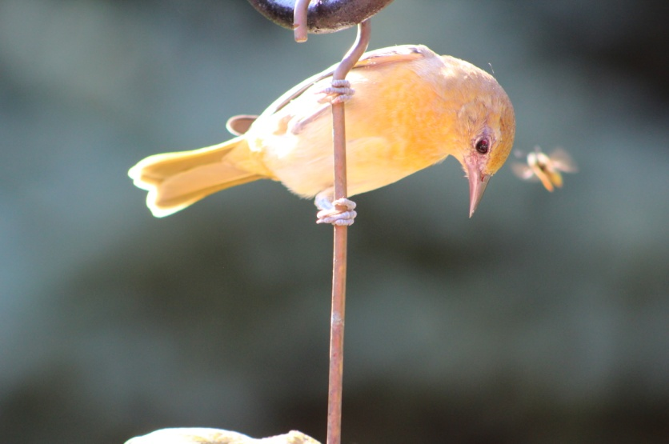
If only the world could see eye to eye!!!!

