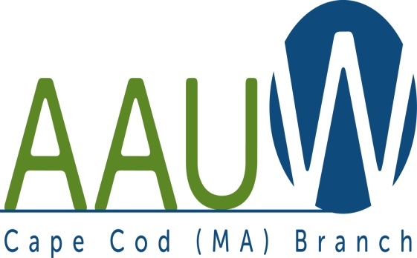 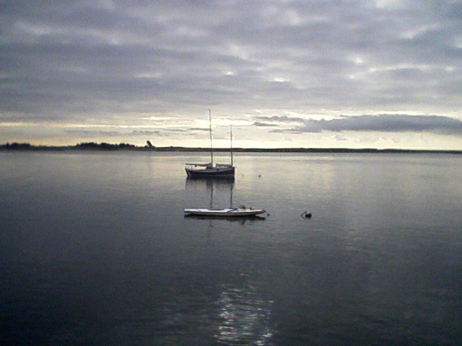

**UNIVERSITY WOMAN AAUW-Cape Cod, Massachusetts Branch, est. 1962 Vol. 41 No.2 October 2014**

**October Meeting Tuesday, October 28th  12:00 p.m. NOON GATHERING AND SOCIAL TIME—LUNCH AT 12:30—SPEAKER AT 1:00**. **WE ARE NOT MEETING AT ST. DAVID’S.**

**We are meeting at a new place!!!! THE OCTOBER MEETING WILL BE HELD AT CARLTON HALL, 1006 Old Bass River Road, Dennis, MA. Marsha will explain in her President’s Message below.**

**PROGRAM: ARTISTS AND ARTISANS**

Local women artists and artisans will discuss their work:

Harvest of Barnstable

Summer House Natural Soaps

Elizabeth Hogan, Artist

Local Jewelry

**Chair:** Carol Mitchell

**Hostesses:** Barbara Mulligan-Rado and Phyllis Rubin

**AAUWAAUWAAUWAAAUWAAUWAAUWAAUWAAUWAAUWAAUWAAUWAAUWAAUW**

**BOARD OF DIRECTORS**

**Marsha Fredericks**

President

**Fran Ziegler Sheila Mennell**

Financial Officer Recording Secretary

* **Rebecca Alden Carol Mitchell Judith Needham**

Vice President, Vice President, Vice President,

AAUW Funds Programs Membership

**AAUWAAUWAAUWAAAUWAAUWAAUWAAUWAAUWAAUWAAUWAAUWAAUWAAUW**

**PRESIDENT’S MESSAGE OCTOBER 2014**

If you didn’t attend the September meeting, be sure to get to October meeting. THE 2014-2015 YEARBOOKS ARE IN!!! Please be sure to let Carol and Beverly know how much you appreciate all their hard work. A big thank you to Beverly’s husband who spent many hours this summer formatting the book. As a result, Winkur’s was able to enter it all into their software in record time and we saved a bundle!

The State Conference in October has been postponed due to scheduling problems with speakers.

SECOND NOTICE: THE OCTOBER MEETING WILL BE HELD AT CARLTON HALL, 1006 Old Bass River Road, Dennis OCTOBER 28, 2014 12:00 NOON GATHERING AND SOCIAL TIME—LUNCH AT 12:30—SPEAKER AT 1:00.

This change of venue has occurred because the cost of meeting at St. David’s has become too high. The last two years we paid the sexton $60.00 per meeting to set up and clean up, in addition to the $100.00 hall rental. This year he wants $75.00 which is outrageous for the service he provides. We will be looking for a permanent home; if you have any suggestions, please contact any member of the board. We have been averaging 25 members per meeting, so we do not need a huge space.

A new interest group has been added—potluck lunch or dinner. At the September meeting there was interest from the Falmouth and Mid Cape area. Let’s meet and talk logistics before the October meeting. The birthday lunch group is off and running. Please see Pam Berube if you are interested in joining other members for a lunch or dinner out during your birthday month.

At the September Board meeting the board and members of the Greta Tomic Memorial Committee decided to establish the “Greta Tomic and Friends NCCWSL Memorial Scholarship Fund.” This fund will provide scholarships for two young women per year to attend NCCWSL at the University of Maryland. The proceeds from the monthly book table will be added to the fund and we will accept any additional donations you care to make either in memory of or in honor of someone. Please speak to Fran Zeigler, our financial officer about this. The committee had hoped to establish this as a continuing fund. The National Convention is coming to San Diego, June 18-21. Early bird registration is open. Pam Berube and I are going. Check out the AAUW website for all the details and consider joining us. Any questions or comments, you know where to find me! Marsha

**AAUWAAUWAAUWAAAUWAAUWAAUWAAUWAAUWAAUWAAUWAAUWAAUWAAUW**

**AAUW – Cape Cod Branch**

**INTEREST GROUPS—NEW AND OLD**

Those interest groups that did not continue through the summer will be picking up again in the fall.

C:\Users\Alice\AppData\Local\Microsoft\Windows\Temporary Internet Files\Content.IE5\9T9R88ZQ\MC900217144[1].wmf**Cape Cod Theater group** enjoyed both musicals and dramas this summer. They are looking forward to seeing Good People in October and Funny Girl in November. If you are interested in the Cape theater offerings contact Beth Flanagan at bethqf@verizon.net or 508 362-4319 to add your name to her list. Attendance is at your interest and convenience and the group often goes to local restaurants for dinner before or after the theater performances.

Four book groups are still going strong.

**Book Group 1** meets on first Thursday at 1:00 contact Barbara Fletcher

**Book Group 3** meets on third Thursday at 1:00 contact Beverly Stec

**Book Group 7** meets on fourth Monday at 1:30 contact Anne Swanson

**Book Group 9** meets on third Thursday at 1:00 contact Mary Smith

**Birthdays Group** which meets bimonthly to celebrate those members whose birthdays fall in Sept./Oct., Nov./Dec., Jan./Feb., Mar./Apr., or May/June with dinner or lunch at a local restaurant. Pam Berube is the coordinator for the group. Contact her at pberube@comcast.net or 508 778-6741 if your birthday is in September or October or if you celebrated this summer and want to join the fun in the fall.

C:\Users\Alice\AppData\Local\Microsoft\Windows\Temporary Internet Files\Content.IE5\DMCCHU5I\MC900311636[1].wmfNEW this year is a proposed **Pot Luck Dinner group** for those of us who like to dine but find that cooking for one in not much fun. If you are interested send me your name at elsa.e.murphy@gmail.com or 508 896-7661. Let’s meet at 11:45 before the September branch meeting to discuss a few “what’s and how’s.”

|  |
| --- |
| **AAUWAAUWAAUWAAAUWAAUWAAUWAAUWAAUWAAUWAAUWAAUWAAUWAAUW** |

|  |
| --- |
| Special announcement about the |

|  |
| --- |
| AAUW-MA Fall Conference  It has been cancelled.  \  **AAUWAAUWAAUWAAAUWAAUWAAUWAAUWAAUWAAUWAAUWAAUWAAUWAAUW**  A Copy of the AAUW Cape Cod Branch Budget for the 2014-2015 year has been attached to this newsletter/email and members should be ready to vote on it at the October meeting. It has been provided to you by Fran Ziegler, our Finance Officer. If you have any questions or concerns please bring them to the meeting.  **AAUWAAUWAAUWAAAUWAAUWAAUWAAUWAAUWAAUWAAUWAAUWAAUWAAUW** |