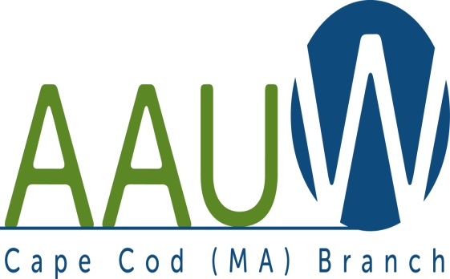 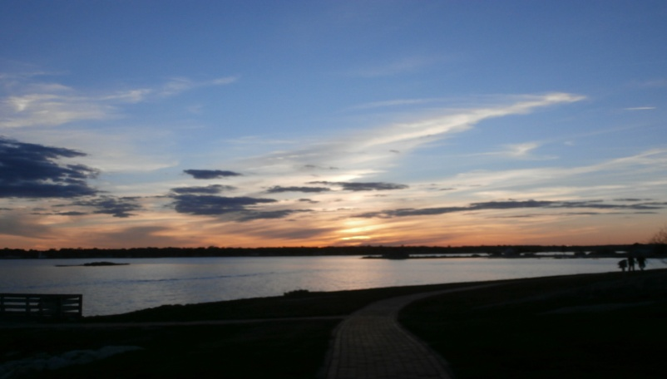

**UNIVERSITY WOMAN AAUW-Cape Cod, Massachusetts Branch, est. 1962 Vol. 41 No.5 March 2015**

**February Meeting Tuesday, March 24th**

12:00 p.m. NOON GATHERING AND SOCIAL TIME—LUNCH AT 12:30—SPEAKER AT 1:00.

**PROGRAM The Unique Challenges of Women Clergy**

**Rev. Dr. Kristen Harper, pastor, Barnstable Unitarian Universalist Church**

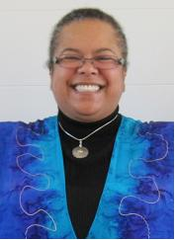

## The Rev. Dr. Kristen Harper

Our senior minister since 2002, the Reverend Dr. Kristen Harper is a lifelong Unitarian Universalist who has served UU churches in Chicago, IL; Lansing, MI; New York, NY; and Ormond Beach, FL. Prior to entering the ministry, she worked for six years with women who were HIV positive and at the UUA in the Office of Diversity Resources. Rev. Harper received her undergraduate degree in print journalism from Boston University and her graduate degree from Meadville Lombard Theological School and the University of Chicago. She is only the second woman of African descent to be called to a UU church as senior minister and is happily married with four cats.

**WE WILL BE MEETING AT THE SOUTH YARMOUTH METHODIST CHURCH. IT IS LOCATED AT 322 OLD MAIN STREET, right across from the Hess Gas Station.**

**AAUWAAUWAAUWAAAUWAAUWAAUWAAUWAAUWAAUWAAUWAAUWAAUWAAUW**

**March Book Discussion**

**March 24th 11am – 12noon**

**(Before the Regular Meeting)**

**The Faith Club: A Muslim, A Christian A Jew—Three Women Search for Understanding**

**By Ranya Idliby, Suzanne Oliver, and Priscilla Warner**

This is the book the board has chosen for everyone to read by this March meeting so that, as we have done in the past, we will have a discussion on the book lead by a member of the AAUW Cape Cod Branch. In these times this book is very appropriate as it is about three friends who were from the three religions who after September 11 started out trying to make a picture book for their children about their three religions and it ended up being a memoir of spiritual reflections in three voices which will give us insight into the three religions and give us lots to discuss at the March meeting. Please get a copy at your favorite bookstore, order it if you must, and read it by the March meeting and bring your comments and questions with you.

**AAUWAAUWAAUWAAAUWAAUWAAUWAAUWAAUWAAUWAAUWAAUWAAUW**

**BOARD OF DIRECTORS**

**Marsha Fredericks**

President

**Fran Ziegler Sheila Mennell**

Financial Officer Recording Secretary

* **Rebecca Alden Carol Mitchell Judith Needham**

Vice President, Vice President, Vice President,

AAUW Funds Programs Membership

**AAUWAAUWAAUWAAAUWAAUWAAUWAAUWAAUWAAUWAAUWAAUWAAUWAAUW**

**PRESIDENT’S MESSAGE MARCH 2015**

Well, March surely did roar in like a lion. Hopefully the lamb will make an appearance within the next three weeks.

The AAUW MA annual meeting was held Friday, March 6 in Boston. Marya Danzer is our new state administrative assistant. I hope you all enjoyed the Bay Stater as much as I did. I will bring several printed copies to the March meeting for those who do not have email. One of our co-presidents, Ruth Ladd, is taking a leave of absence, but Margaret Chapowlski will carry on and as her present work is in Massachusetts, she will be more present. Barbara Burgo graciously offered to fill in as temporary Membership VP, as well as continuing as C/U Partner Chair. Robin DeMott has agreed to continue as Chief Financial Officer. The State organization is in need of a CoPresident and Membership VP. Is there anyone out there that could step forward to fill one of these positions?

Stacy Fatale, the state Public Policy chair, announced that AAUW will be working in conjunction with other organizations to effect legislation within the state regarding equal pay, paid sick days, and other issues that affect women. There will be a gathering of women on the steps of the State House on April 14, EQUAL PAY DAY, from 2-5pm. The collaborators hope to have 100 women there—I hope some of you will join me. (see also what our branch will be doing)

Following the annual meeting we joined the United Nations Association of Greater Boston for a screening of the documentary “Positively Beautiful,” the story of five HIV positive South Africans. Although HIV/AIDS has not been much in the public eye of late, the epidemic continues; numbers are not increasing, but neither are they decreasing significantly, except perhaps in the case of babies born to women who are HIV positive. Diveena Coopan, the South African, first time film maker, was present as part of the panel discussion. This film will be shown at least two independent film festivals in the coming year. Go see it if you can.

AAUW Cape Cod will once again have a table at Cape Cod Mall on Equal Pay Day, April 14. Details of this outreach will be announced at the March meeting. Can you spare 2 hours to help educate the public about equal pay?

Applications are coming in for our NCCWSL scholarships.

We will be part of Envision the Future, a weeklong residential STEM camp, to be held this summer at Bridgewater State University. We have formed a replication team with Dennis Yarmouth Schools and will be reproducing some elements of the camp here on Cape next year. The plan for the future is to work under the auspices of the Cape and Island STEM network with other organizations to provide a residential program for Cape Cod girls. Any member who is interested in seeing how this works is welcome to attend for a day, or half day.

Lynn Howard and the South Shore branch will once again present an April vacation STEM workshop. I hope to go see what she does and how it works, April 8-11 at Weymouth High School from 8am-1pm. I would love for any interested Cape Cod branch members with an interest in STEM careers attend with an eye to perhaps replicating Lynn’s program—one in Falmouth area, on in the mid Cape. This need not be a huge time commitment.

Hope to see many of you soon.

Marsha

**AAUWAAUWAAUWAAAUWAAUWAAUWAAUWAAUWAAUWAAUWAAUWAAUWAAUW**

Our “HAVE a HEART- VOLUNTEER” program in February introduced us to five wonderful programs our members can volunteer at, or register the time they do volunteer at, trying to help Cape Cod Volunteers make their Million Hour Challenge. **Lisa McNeill** spoke to us on behalf of the Cape Cod Volunteers and requested if any of our members volunteer on Cape Cod that we become one of the million! Volunteer & Log your hours @CCVOLUNTEERS.ORG and watch the number grow. Every time you go volunteer you log on and register your hours. If you are looking for a place to volunteer they will be happy to place you with a group that will match your interests and talents. **Jo-Ann Richard** sweetened our program bringing each of us there a bag of candy. She is the Director of Volunteer Services for Hope Health, formerly Hospice. She informed us of the many ways we could help the caregivers and families of the people who are in the Hospice program, and in other programs they sponsor. **Dawn Walnut** spoke on behalf of Habitat for Humanity and she was so proud of the houses that they were building but told us of other ways that we could help the struggling families they help. There is more to Habitat for Humanity than just building Houses and there is plenty we can do besides hammer nails, which many of us can no longer do!!! We can buy grocery cards, or give the new home owner a set of sheets! **Darlene Skog** told us of the new programs in Girl Scouts that can use women to be leaders and helper in our area. Former scouts are always welcome and those who have no experience are too!! They have girls on waiting lists for troops! **Caroline Corrigan** talked about mentoring the homeless women at Homeless Not Hopeless, Inc. and read from the book, ”Sea Glass” that the women in the house at 22 Main Street had just written and published. Please feel free to contact any of these women if you feel you would like to get involved in their programs.

**AAUWAAUWAAUWAAAUWAAUWAAUWAAUWAAUWAAUWAAUWAAUWAAUWAAUW**

**Equal Pay Day April 14th**

**Equal Pay Day** — the annual day in April that symbolizes how long it takes for women’s earnings to catch up to men’s earnings from the previous year — is a powerful opportunity to organize action in our communities.

This year, given all the public attention to pay equity, increased legislative activity at the state level, and the possibility of new developments on the federal level, AAUW National is confident that we can surpass the [number of events held in 2014](http://www.aauw.org/article/how-to-equal-pay-day/). Our Cape Cod Branch will be hosting a booth at the Cape Cod Mall from 2pm – 8pm and we are looking for at least two members each hour to sign up to cover our booth. Bo was asked to look into this date as it intrigued her. In 1971 when she started teaching the Equal Pay Day was in August. **So in** **44 years we have moved 4 months!!!!** She applied that to the two nieces she has had born this year. If history repeats itself they will have to be 44 to go the next 4 months we need to get pay equity!! Think of your own daughters, granddaughters, nieces, and other female relatives. We need to become more active and not make them wait another 44 years to achieve this goal! Sign up with Marsha at the March Meeting!!!

**AAUWAAUWAAUWAAAUWAAUWAAUWAAUWAAUWAAUWAAUWAAUWAAUWAAUW**

**Membership Changes:**

**Frances H. Shibata**

110 Dillingham Avenue, Unit 314

Falmouth, MA 02540-3358

Phone: Same

Email: [edwardshibata@comcast.net](mailto:edwardshibata@comcast.net)

**AAUWAAUWAAUWAAAUWAAUWAAUWAAUWAAUWAAUWAAUWAAUWAAUWAAUW**

AAUW national has a Book Club for all its members! More information is on its web site. We can suggest titles to other branches as well as get suggestions from them. You pay your dues and rarely take advantage of all the materials and information they offer. AAUW’s website is: http:/www.aauw.org

Please take advantage of this site!

**AAUWAAUWAAUWAAAUWAAUWAAUWAAUWAAUWAAUWAAUWAAUWAAUWAAUW**

**AAUW – Cape Cod Branch**

**INTEREST GROUPS—NEW AND OLD**

C:\Users\Alice\AppData\Local\Microsoft\Windows\Temporary Internet Files\Content.IE5\9T9R88ZQ\MC900217144[1].wmf

**Pot Luck Dinner Group** Elaine Bono will hostess the next meeting in March. The exact date is yet to be decided, but it will again be a late lunch. Volunteers to bring one dish and/or new members are welcome. For information contact Elsa Murphy at 896-7661 or [elsa.e.murphy@gmail.com](mailto:elsa.e.murphy@gmail.com)

**Cape Cod Theater group** If you are interested in the Cape theater offerings contact Beth Flanagan at bethqf@verizon.net or 508 362-4319 to add your name to her list. Attendance is at your interest and convenience and the group often goes to local restaurants for dinner before or after the theater performances.



Four book groups are still going strong.

**Book Group 1** meets on first Thursday at 1:00 contact Barbara Fletcher

**Book Group 3** meets on third Thursday at 1:00 contact Beverly Stec

**Book Group 7** meets on fourth Monday at 1:30 contact Anne Swanson

**Book Group 9** meets on third Thursday at 1:00 contact Mary Smith



Birthdays Group The next Birthdays lunch will be for Jan. / Feb celebrants. If Pam Berube has not yet contacted you call her at 508 778-6741 for time and date

.C:\Users\Alice\AppData\Local\Microsoft\Windows\Temporary Internet Files\Content.IE5\DMCCHU5I\MC900311636[1].wmfBook Exchange is intended to be an ongoing activity. Response at first meeting was enthusiastic. If you have books you want to share, bring them to next branch meeting.

**AAUWAAUWAAUWAAAUWAAUWAAUWAAUWAAUWAAUWAAUWAAUWAAUW**

|  |
| --- |
|  |

|  |
| --- |
|  |
|  |